Final Assignment

**Introduction to Database**

Freelancer Website Management System

**Scenerio**

In a Freelancer website Management system Buyer has a unique buyer id(primary key), a buyer city, country and multiple phone number. Multiple buyer works freelancer website with seller. Each seller has a unique seller id(primary key), seller name, phone number and multiple skill(freelancer, buyer & seller where all these relations are many to many relation). Each multiple seller contest each to another client. It has a unique client id(primary key), email, tips and name(seller, contest & client where all these relations are one to many relation). Client order by buyer then they give him payment document. Each buyer order relation by each Payment. Payment has a payment amount, payment date and unique payment id (primary key). Here buyer, payment & order are in many to many relation.

**ER Diagram**

In a Freelancer website Management system Buyer has a unique buyer id, a buyer city, country and multiple phone number. Multiple buyer works freelancer website with seller.

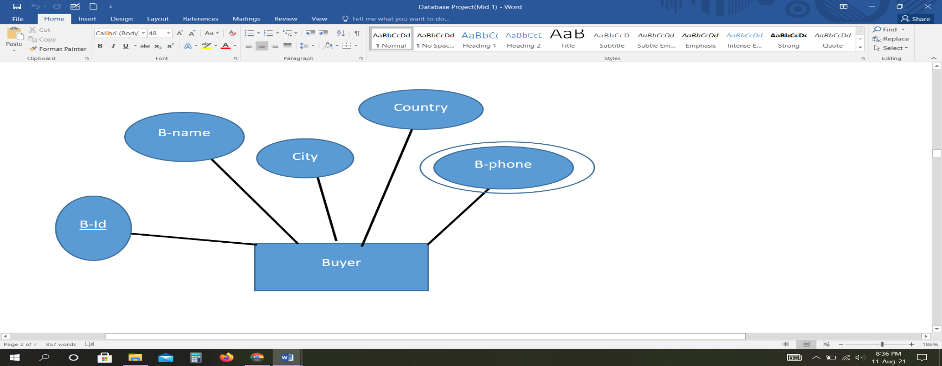

Each seller has a unique seller id, seller name, phone number and multiple skill.

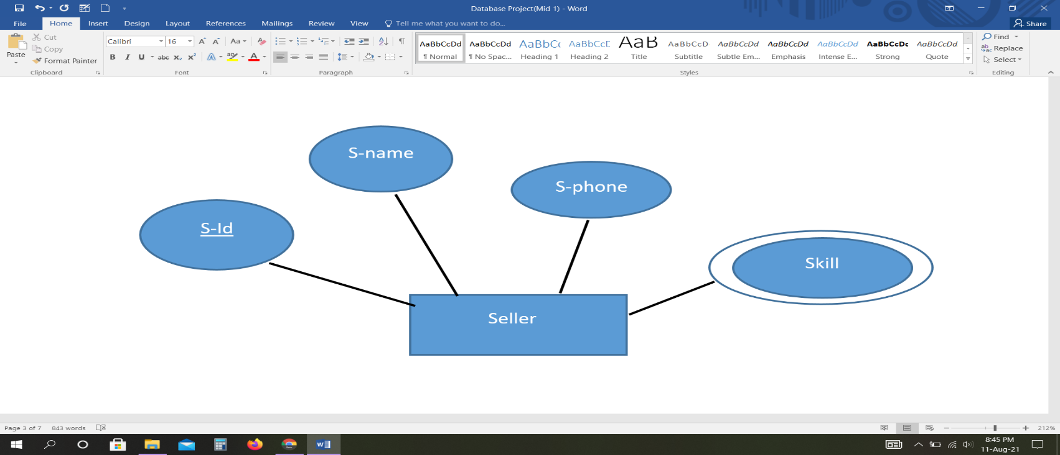

In a Freelancer website Management system Buyer has a unique buyer id, a buyer city, country and multiple phone number. Multiple buyer works freelancer website with seller. Each seller has a unique seller id, seller name, phone number and multiple skill. (freelancer, buyer & seller where all these relations are many to many relation).

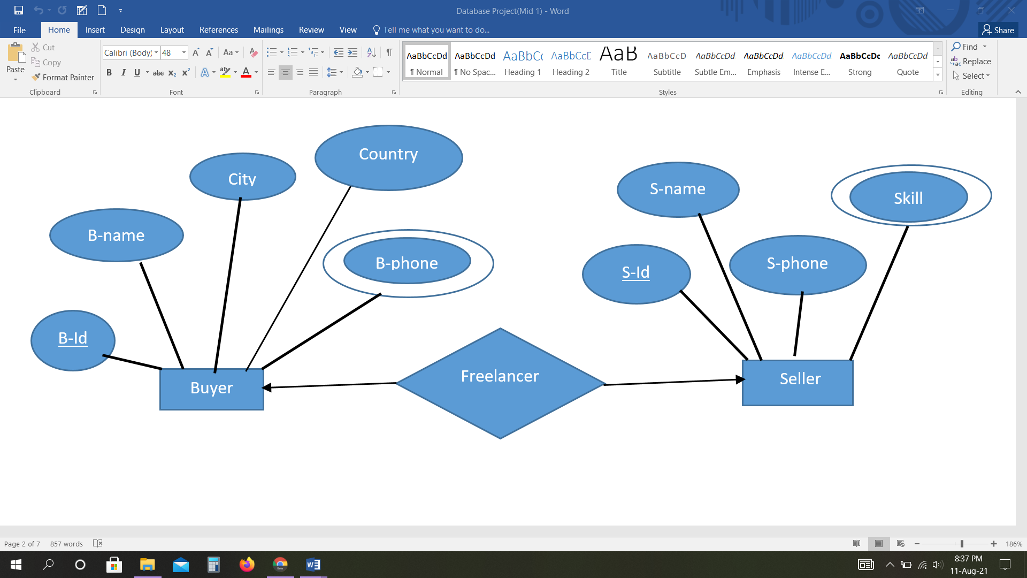

Each multiple seller contest each to another client. It has a unique id, email, tips and name.

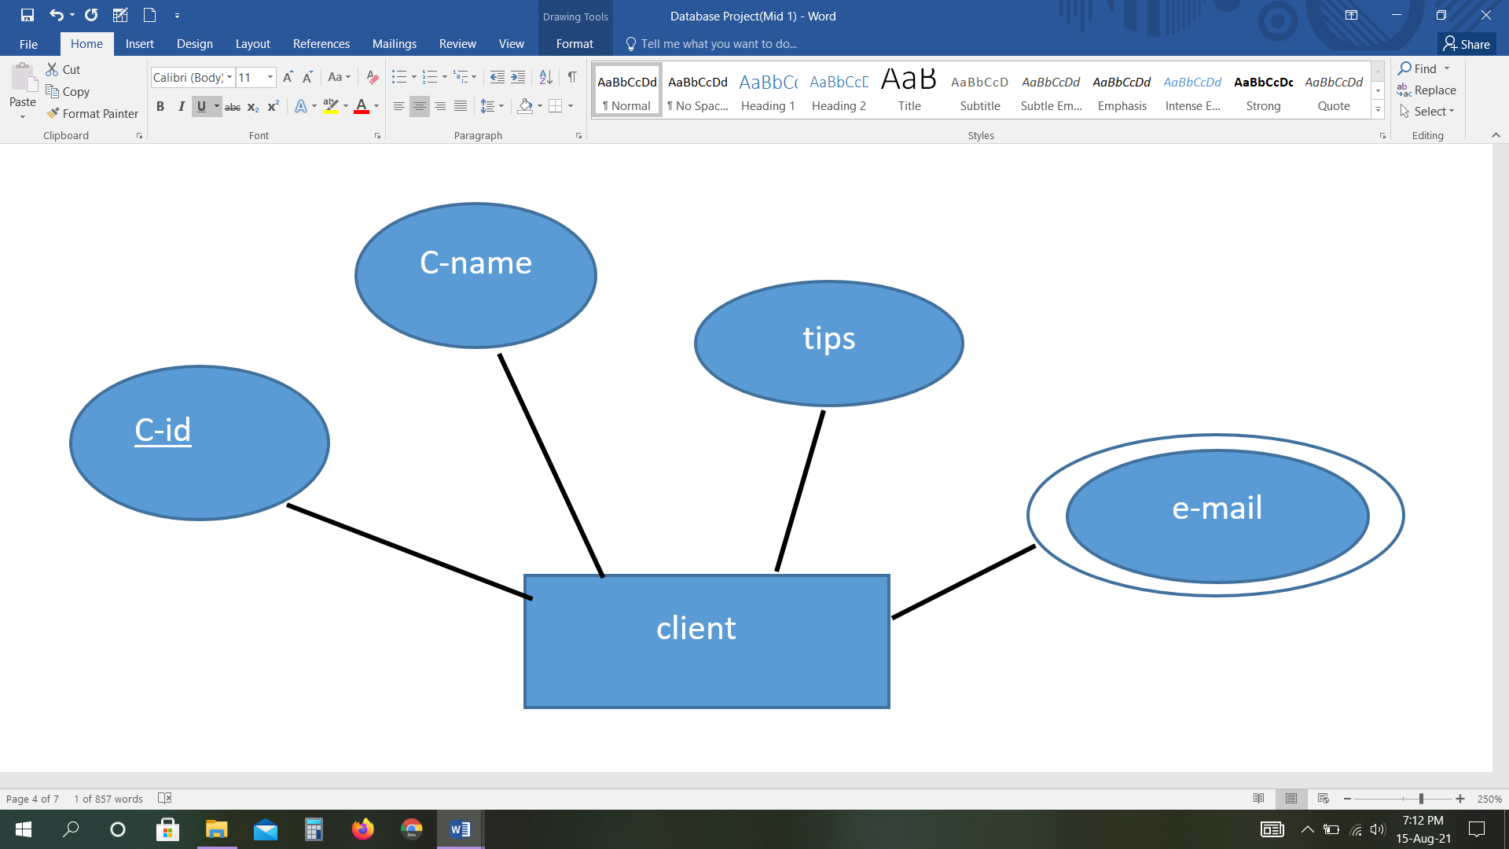

In a Freelancer website Management system Buyer has a unique buyer id, a buyer city, country and multiple phone number. Multiple buyer works freelancer website with seller. Each seller has a unique seller id, seller name, phone number and multiple skill. Each multiple seller contest each to another client. It has a unique client id, email, tips and name ( seller, contest & client where all these relations are one to many relation).

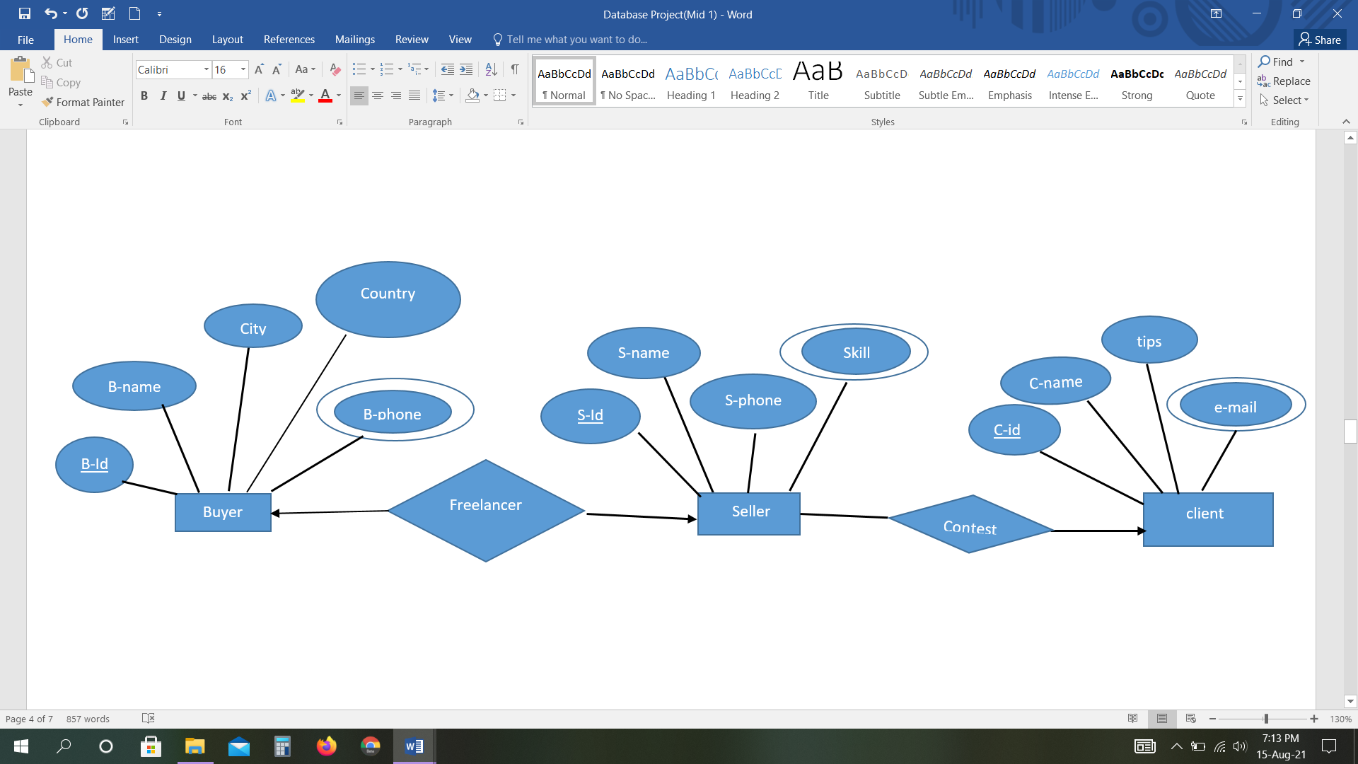

Each buyer order relation by each Payment. Payment has a payment amount, payment date and payment unique id (primary key).

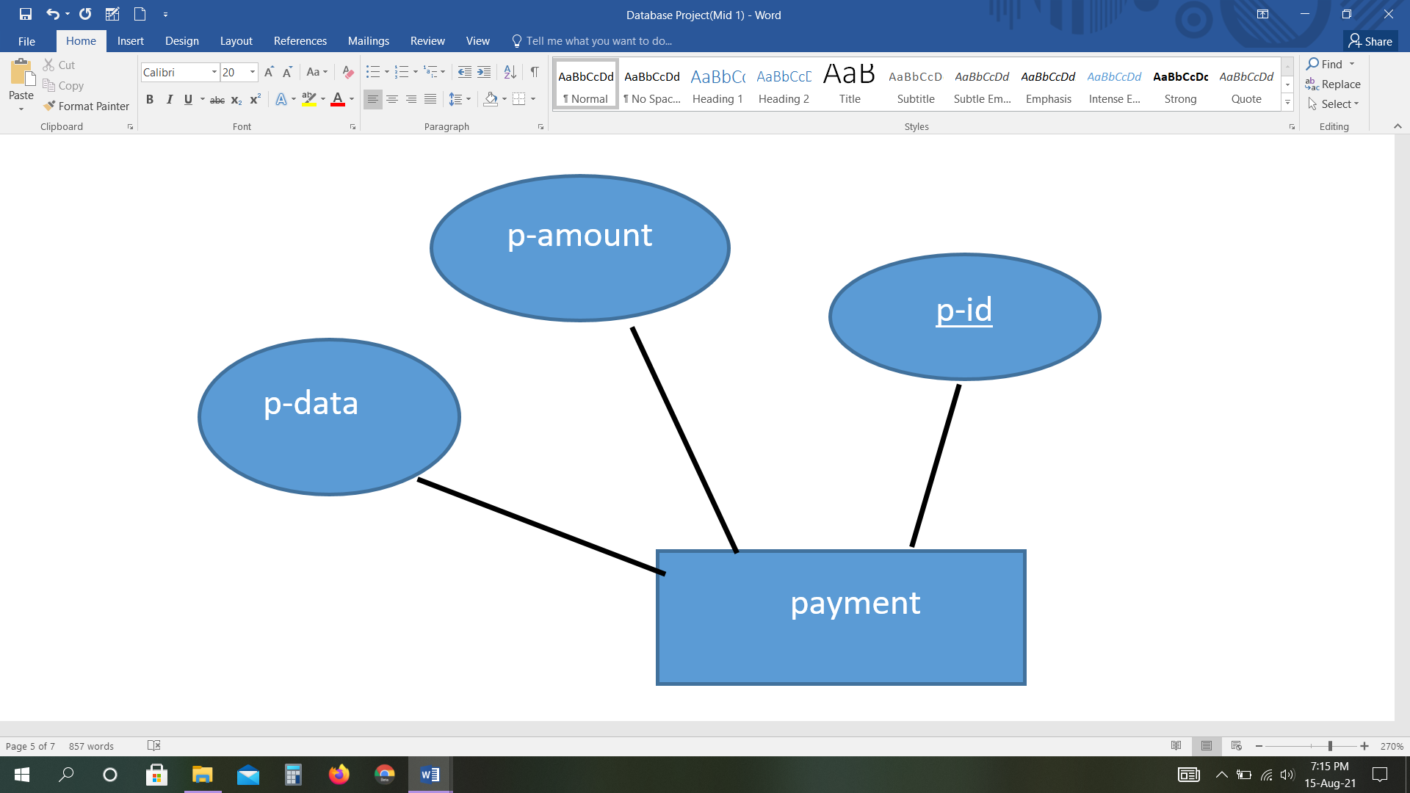

In a Freelancer website Management system Buyer has a unique buyer id(primary key), a buyer city, country and multiple phone number. Multiple buyer works freelancer website with seller. Each seller has a unique seller id(primary key), seller name, phone number and multiple skill. Each multiple seller contest each to another client. It has a unique id, email, tips and name. Client order by buyer then they give him payment document. Each buyer order relation by each Payment. Payment has a payment amount, payment date and unique payment id. Here buyer, payment & order are in many to many relation.

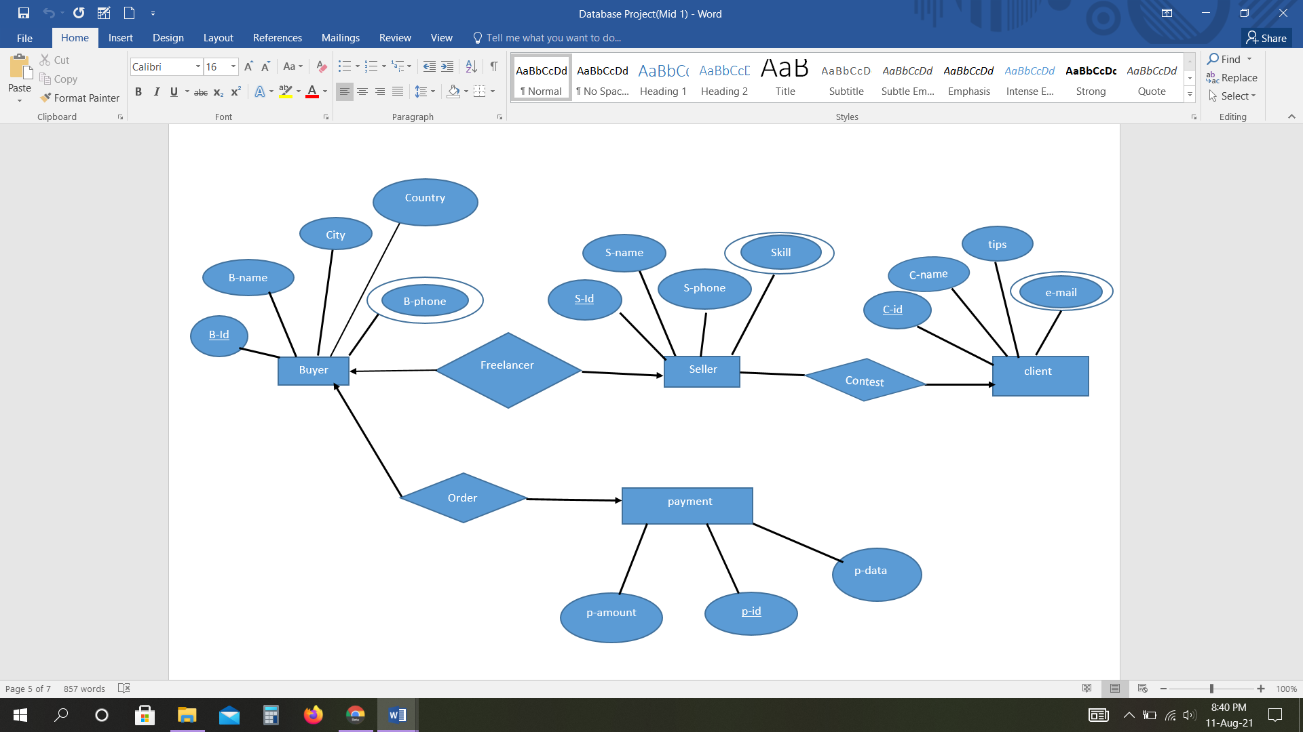

**Normalization**

**Freelancer** ( B_id , B_name , city , country , B_phone , S_id , S_name , S_phone , skill )

**1NF**: B_phone , skill are multivalued

**2NF**: B_id , B_name , city , country , B_phone

S_id , S_name , S_phone , skill

**3NF**: B_id , B_name ,B_phone

L_id , city , country

S_id , S_name , S_phone , skill

**Table for Freelancer:**

1. B_id , B_name , L_id , S_id
2. L_id , city , country
3. S_id , S_name , S_phone
4. B_id , B_phone
5. S_id , skill

**Order** ( B_id , B_name , city , country , B_phone ,P_id , P_amount , P_date )

**1NF**: B_phone are multivalued

**2NF**: B_id , B_name , city , country , B_phone

P_id , P_amount , P_date

**3NF**: B_id , B_name ,B_phone

E_id , city , country

P_id , P_amount , P_date

**Table for Order:**

1. B_id , B_name , E_id , P_id
2. E_id , city , country
3. P_id , P_amount , P_date
4. B_id , B_phone

**Contest** ( S_id , S_name , S_phone , skill ,C_id , C_name , tips , e-mial )

**1NF**: Skill , e-mail are multivalued

**2NF**: S_id , S_name , S_phone , skill

C_id , C_name , tips , e-mial

**3NF:** no transitive dependency

S_id , S_name , S_phone , skill

C_id , C_name , tips , e-mial

**Table for Contest:**

1. S_id , S_name , S_phone , C_id
2. C_id , C_name , tips
3. S_id , Skill
4. C_id , e-mail

**Final Table:**

1. B_id , B_name , L_id , S_id

2. L_id , city , country

3. S_id , S_name , S_phone

4. B_id , B_phone

5. S_id , skill

6. B_id , B_name , E_id , P_id

7. E_id , city , country

8. P_id , P_amount , P_date

9. S_id , S_name , S_phone , C_id

10. C_id , C_name , tips

11. C_id, Email

**Create Table**

create table byer(

b_id number(12) primary key,

b_name varchar2(18),

l_id number(12),

s_id number(12))

alter table byer add constraint ax1 foreign key(l_id)references bio_byer(l_id)

alter table byer add constraint ax2 foreign key(s_id)references seller(s_id)

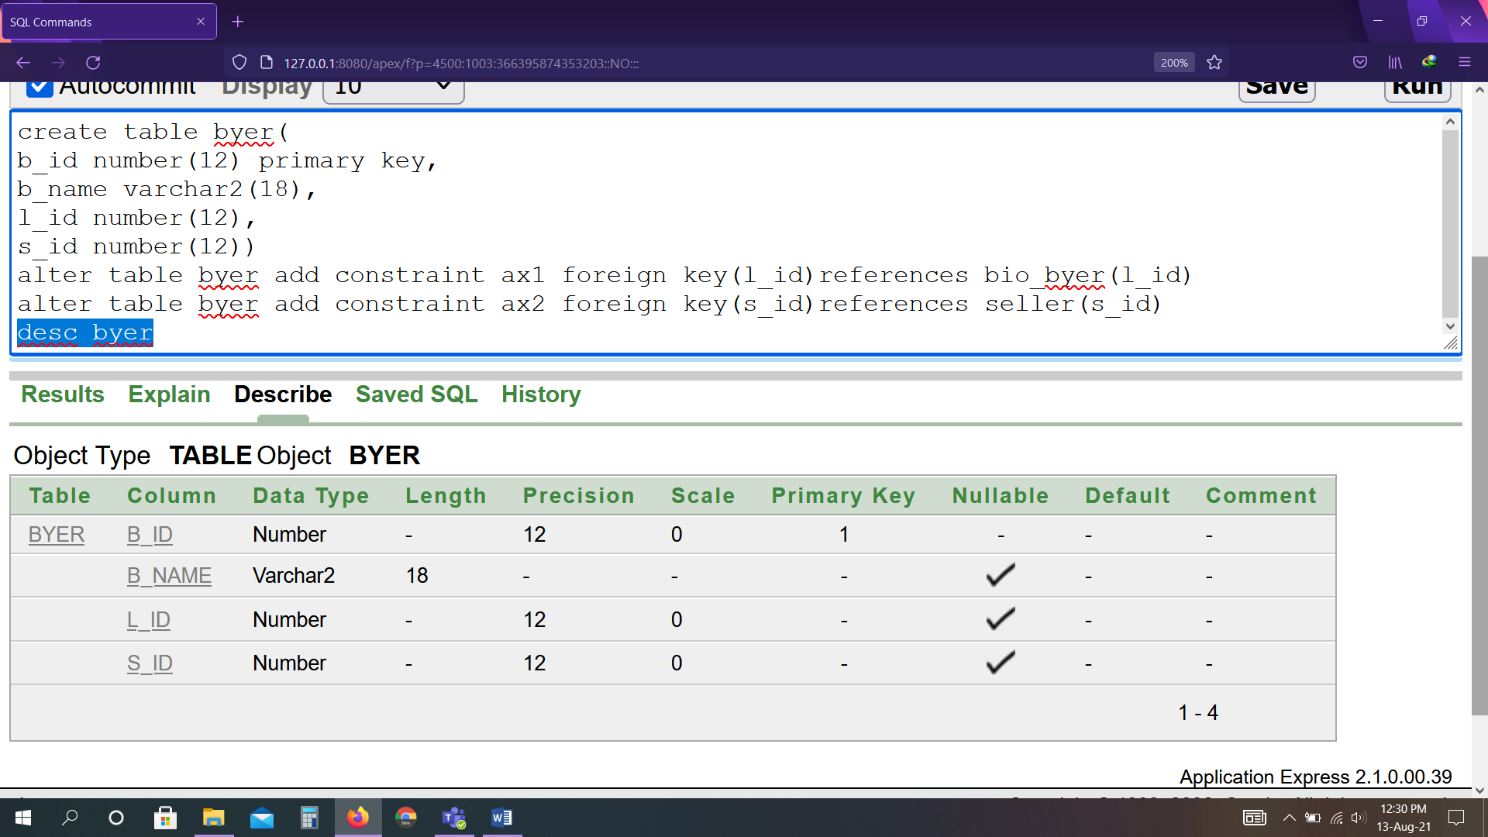

create table bio_byer(

l_id number(12),

city varchar2(8),

country varchar2(10))

alter table bio_byer add constraint aze1 primary key(l_id)

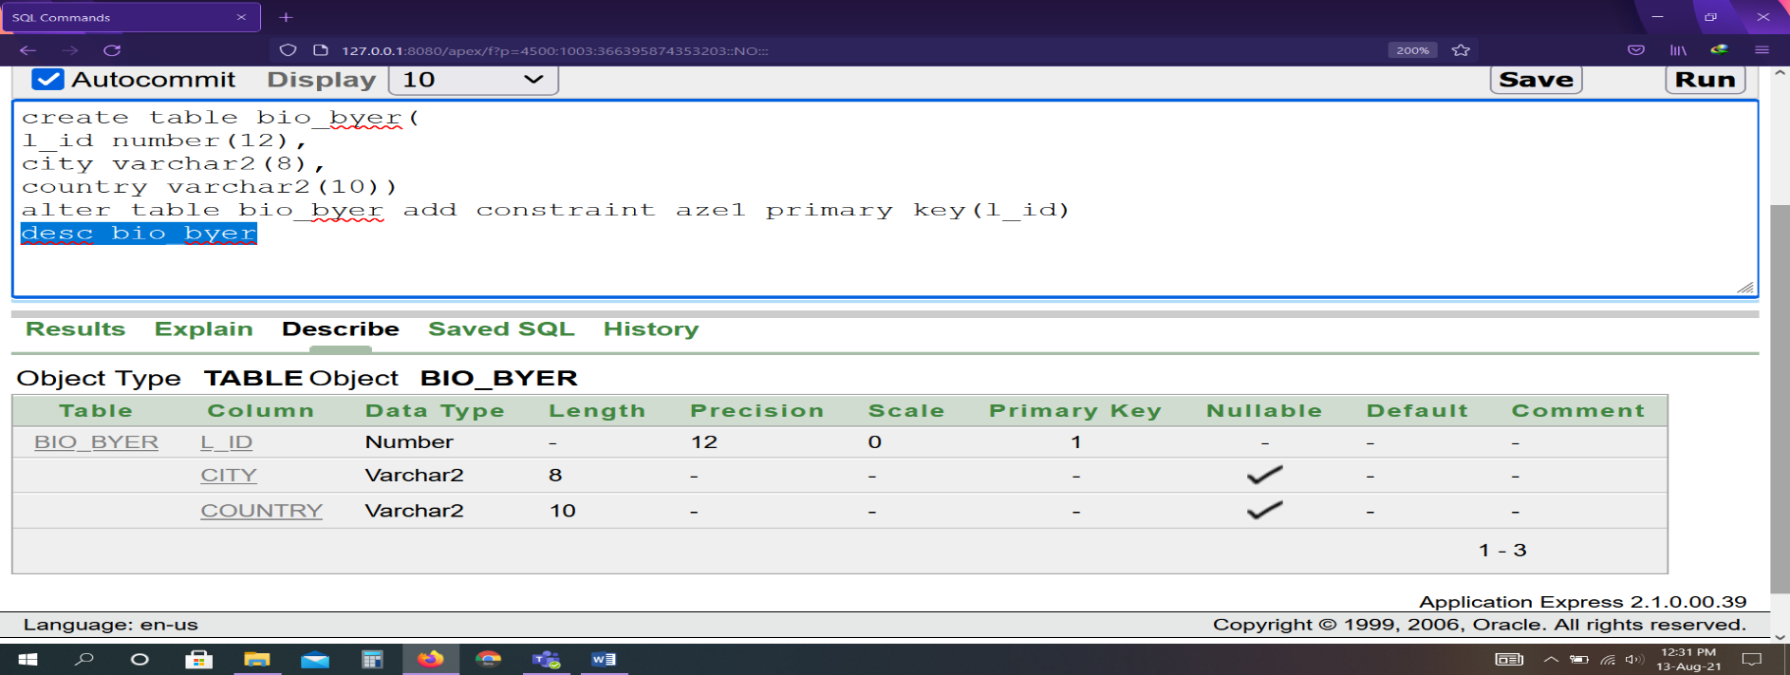

create table seller(

s_id number(12),

s_name varchar2(18),

s_phone number(11))

alter table seller add constraint aze2 primary key(s_id)

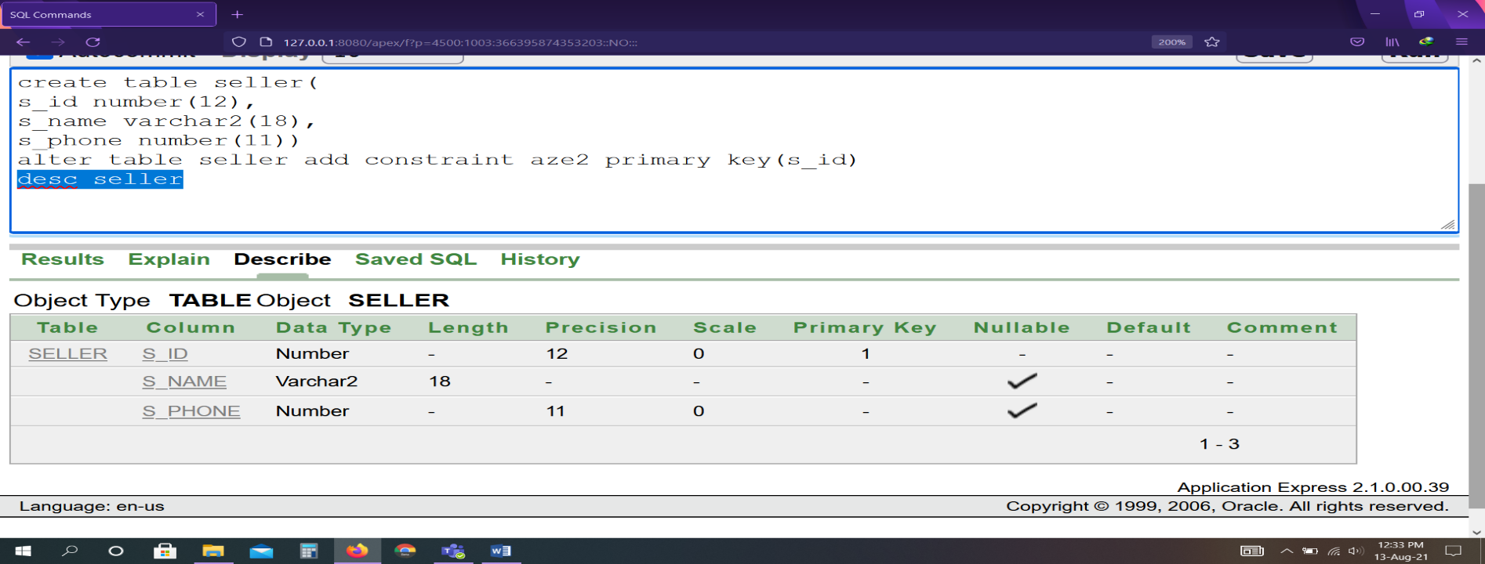

create table byer_num(

b_id number(12),

b_phone number(11))

alter table byer_num add constraint aze3 primary key(b_id,b_phone)

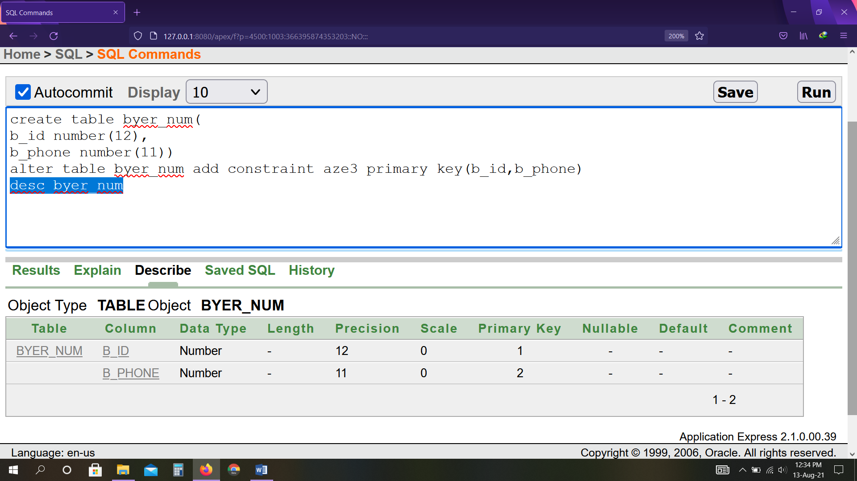

create table seller_lang(

s_id number(12),

skill varchar2(18))

alter table seller_lang add constraint aze4 primary key(s_id,skill)

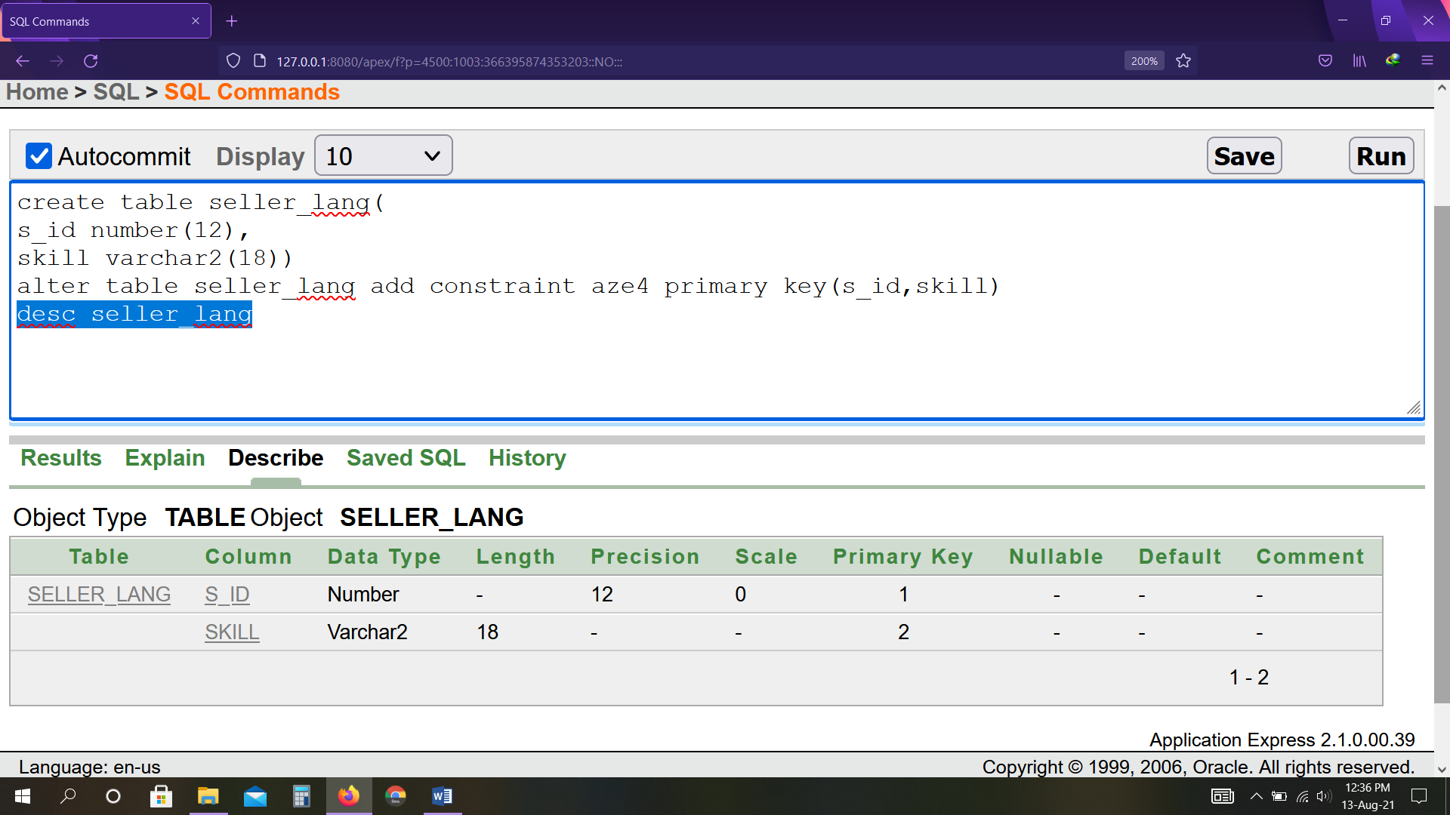

create table byer_1(

b_id number(12),

b_name(12),

e_id number(12),

p_id number(12))

alter table byer_1 add constraint aze5 primary key(b_id)

Alter table byer_1 add constraint ax3 foreign key(e_id)references bio_byer1(e_id)

Alter table byer_1 add constraint az9 foreign key(p_id)references payment(p_id)

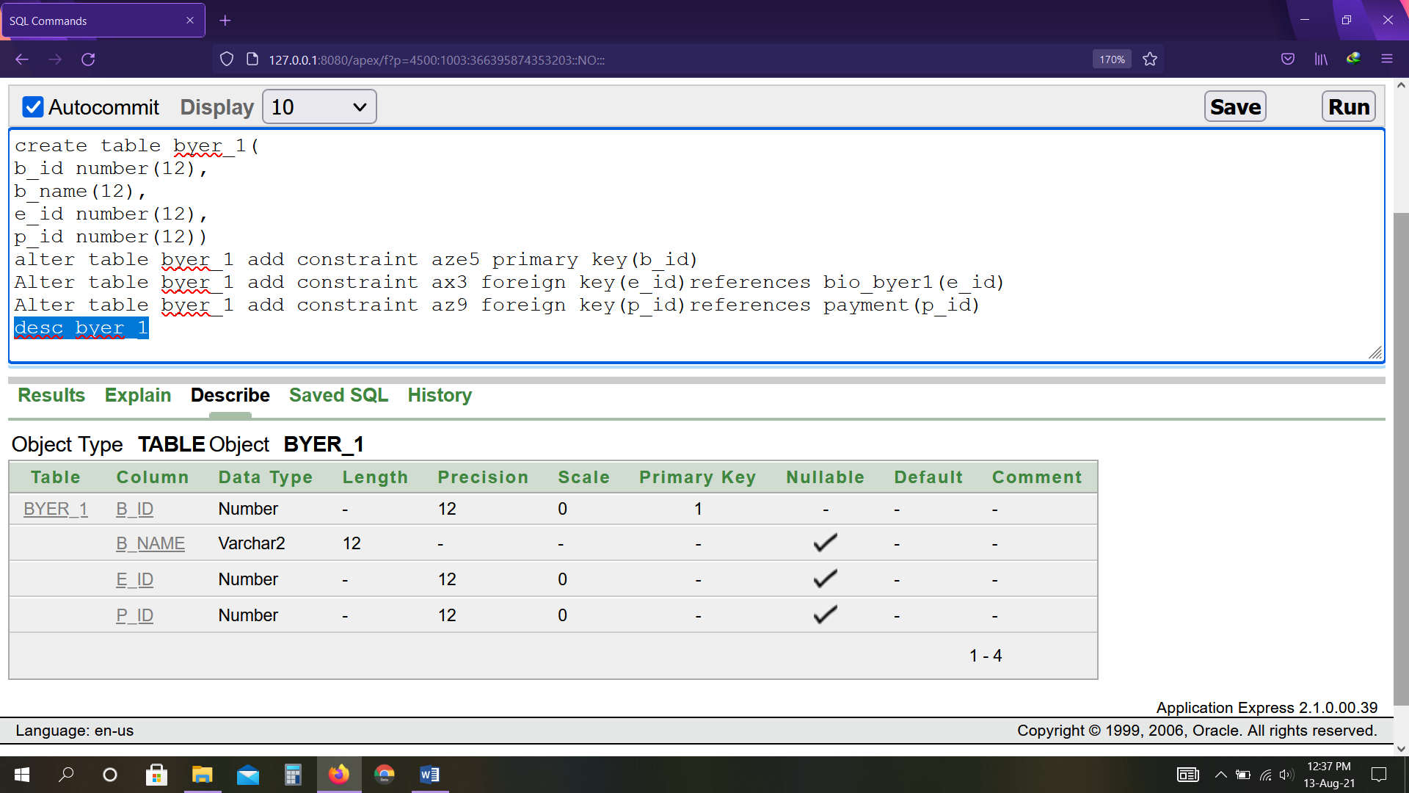

create table bio_byer1(

e_id number(12),

city varchar2(8),

country varchar2(10))

alter table bio_byer1 add constraint azew primary key(e_id)

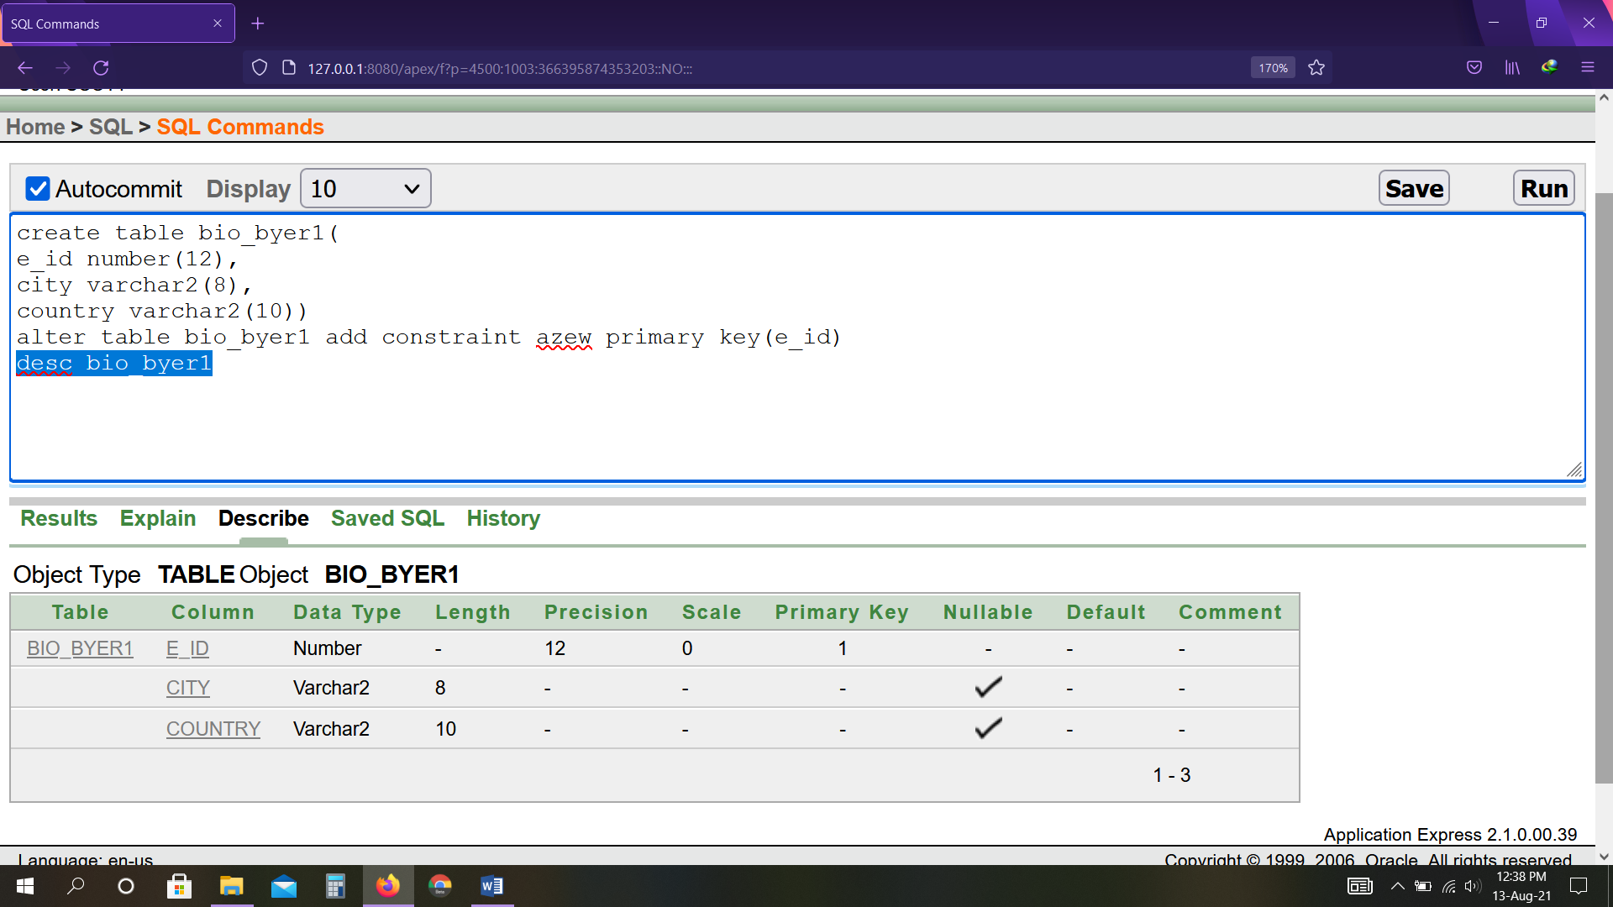

create table payment(

p_id number(12),

p_amount decimal(8,2),

p_date date (7))

alter table payment add constraint aze7 primary key(p_id)

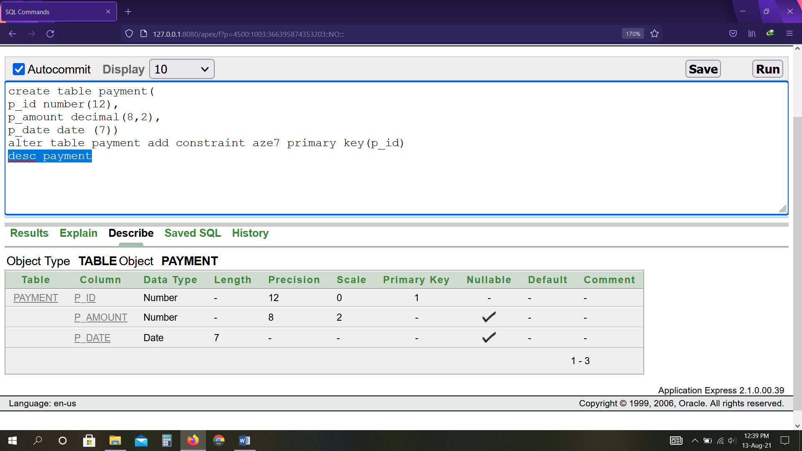

create table seller2(

s_id number(12),

s_name varchar2(18),

s_phone number(11),

c_id number(12))

alter table seller2 add constraint aze8 primary key(s_id)

Alter table seller2 add constraint ax5 foreign key(c_id)references client(c_id)

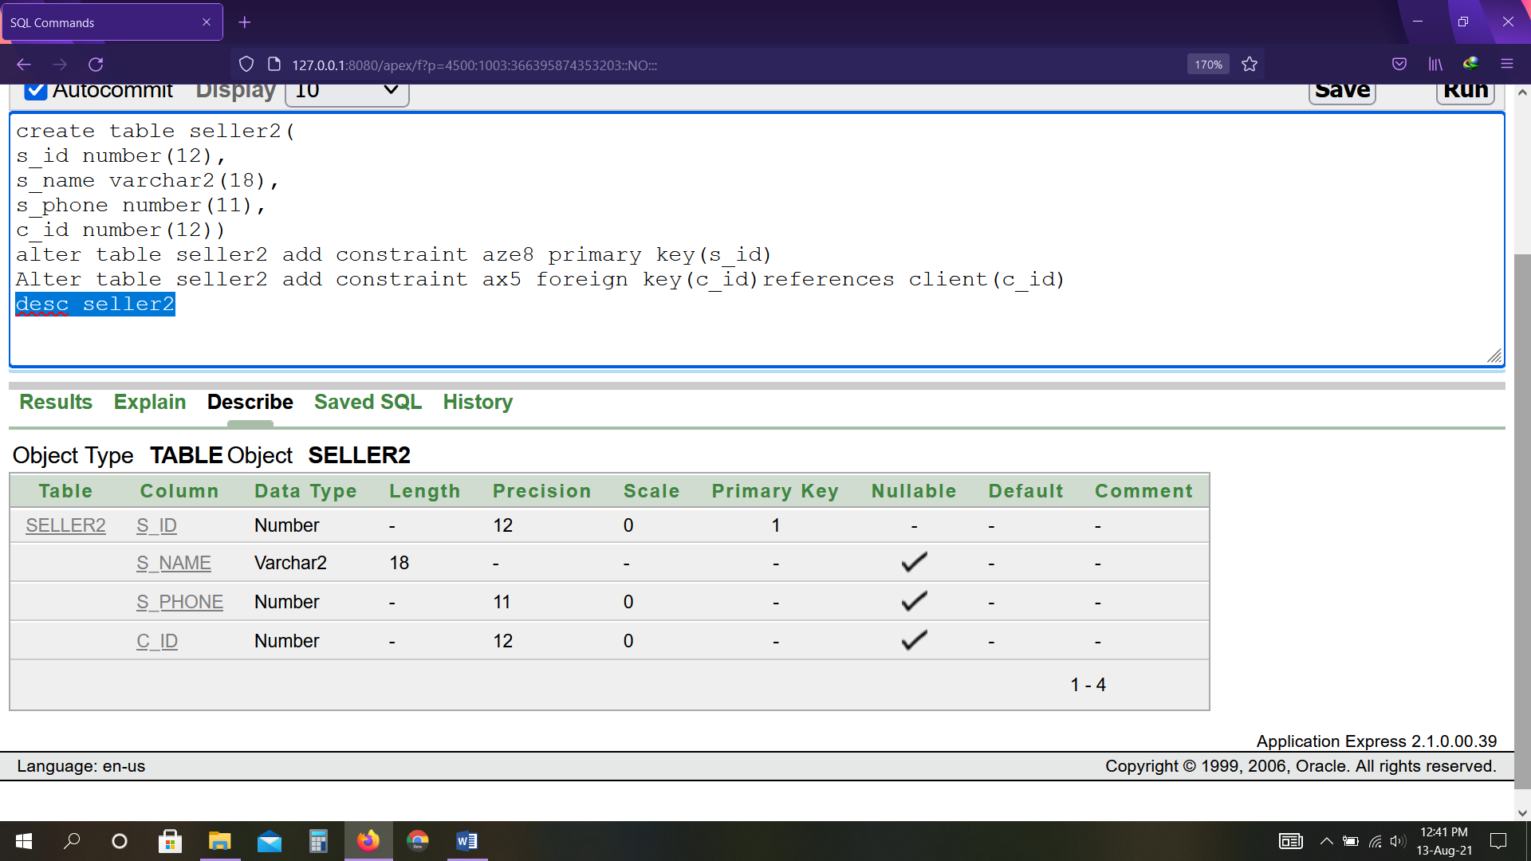

create table client(

c_id number(12),

c_name varchar2(18),

tips decimal(8,2))

alter table client add constraint aze9 primary key(c_id)

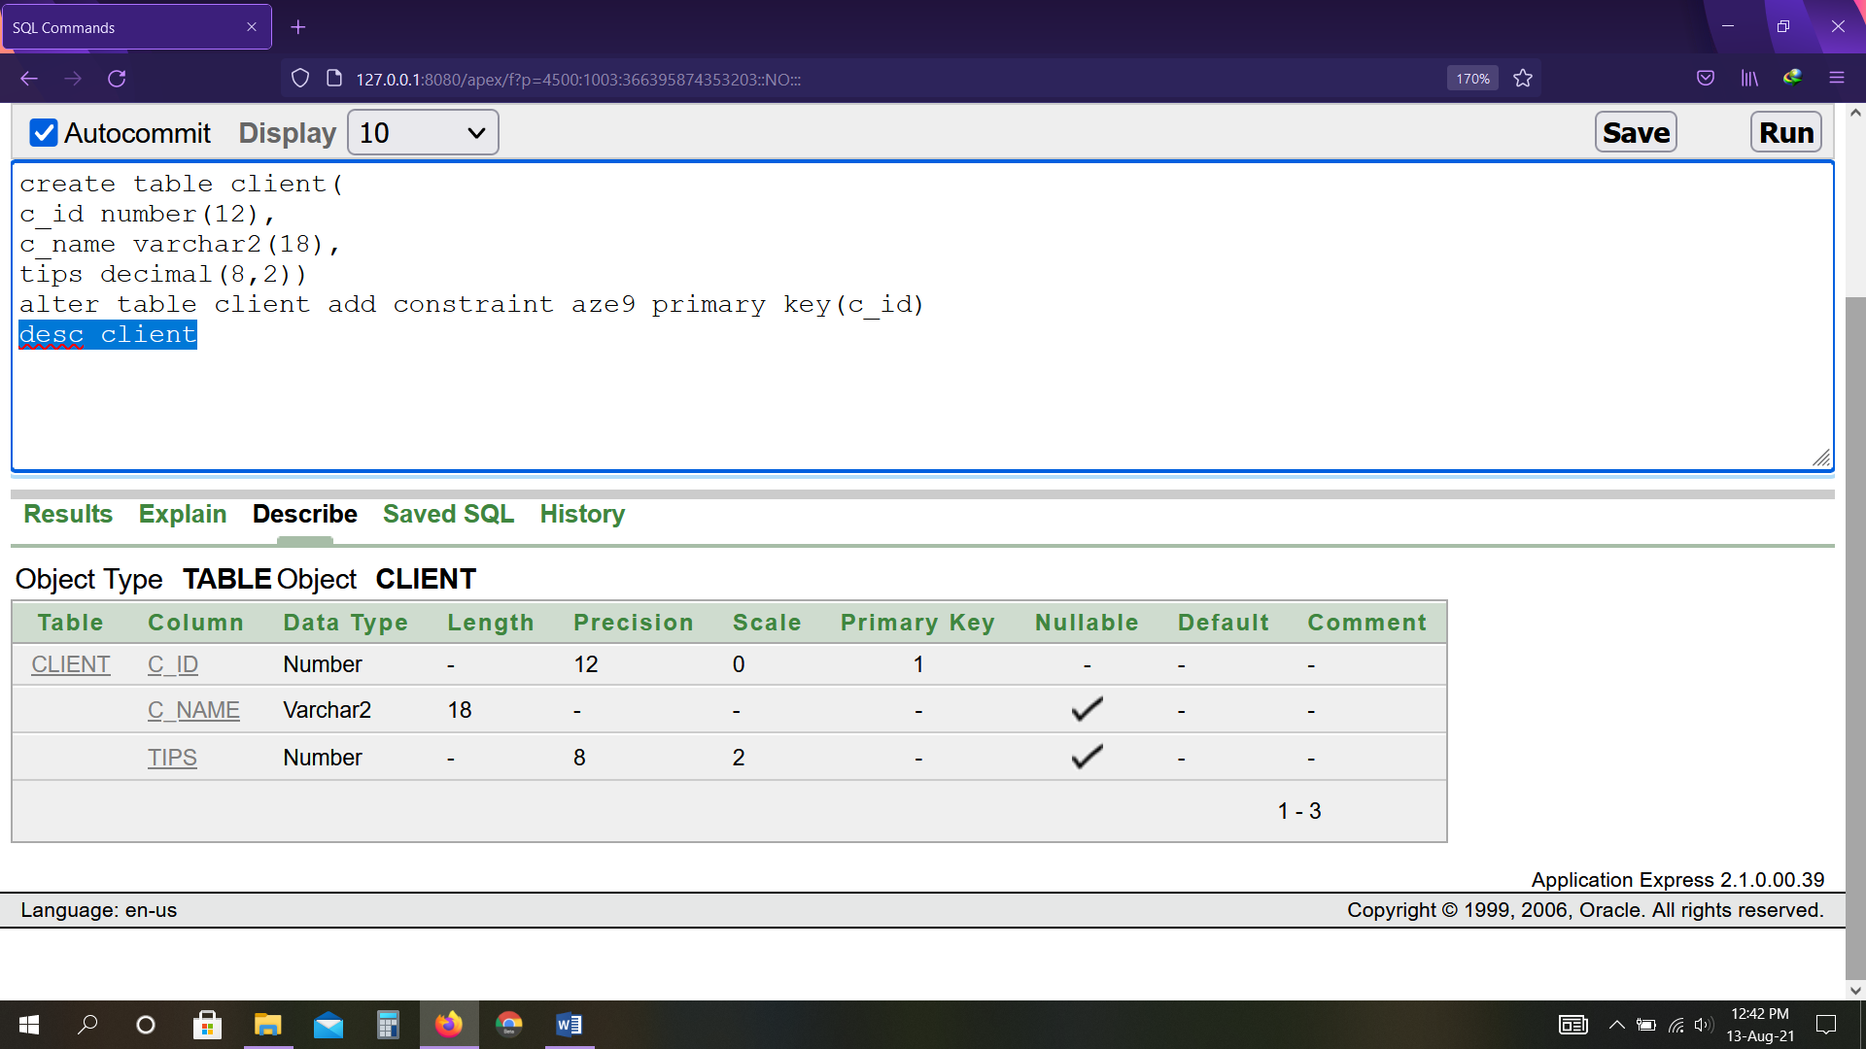

create table bio_client(

c_id number(12),

email varchar2(30))

alter table bio_client add constraint aze10 primary key(c_id,email)

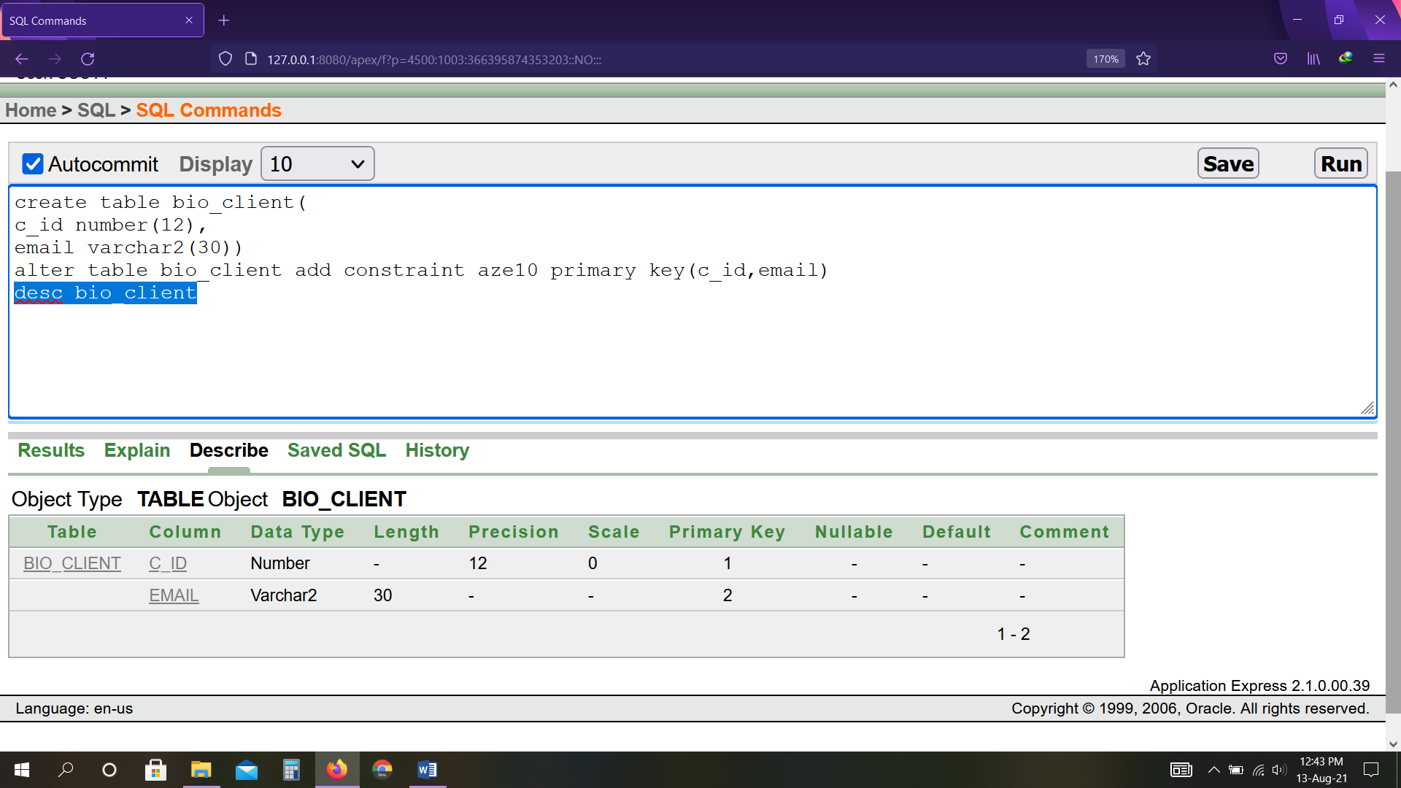

**Data Insertion**

insert into byer values(1001,'Alif',2001,3001)

insert into byer values(1002,'Rana',2002,3002)

insert into byer values(1003,'Fariad',2003,3003)

insert into byer values(1004,'Niloy',2004,3004)

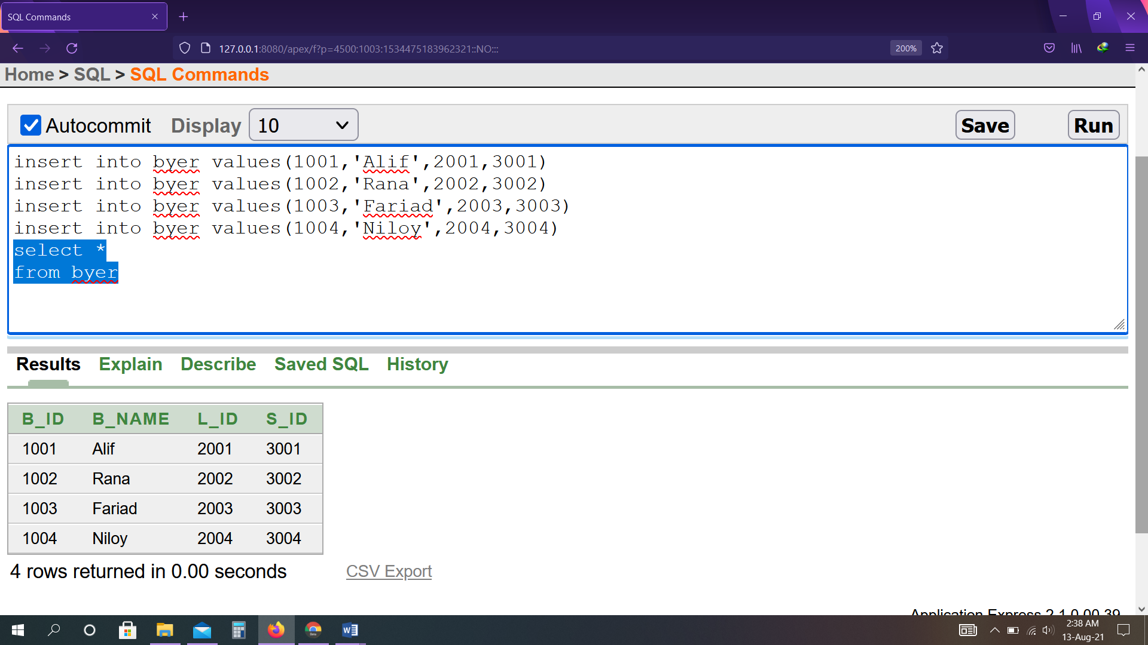

insert into bio_byer values(2001,'Dhaka','Bangladesh')

insert into bio_byer values(2002,'Delhi','India')

insert into bio_byer values(2003,'Riyadh','Saudi Arab')

insert into bio_byer values(2004,'New york','America')

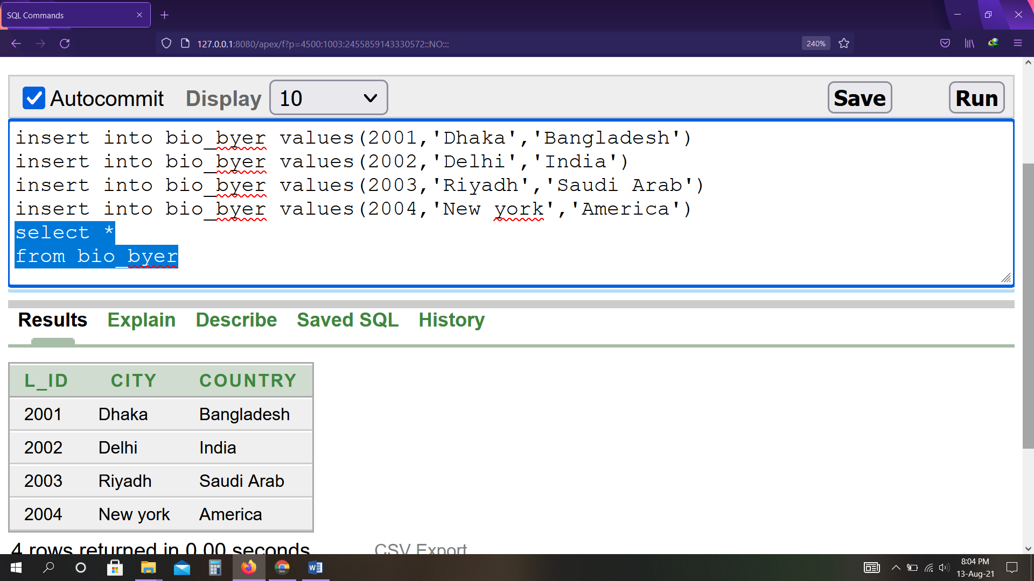

insert into seller values(3001,'Reza',01727346924 )

insert into seller values(3002,'Mehedi',01825346923 )

insert into seller values(3003,'Bristy',01925346927 )

insert into seller values(3004,'Sabbir',01522346928 )

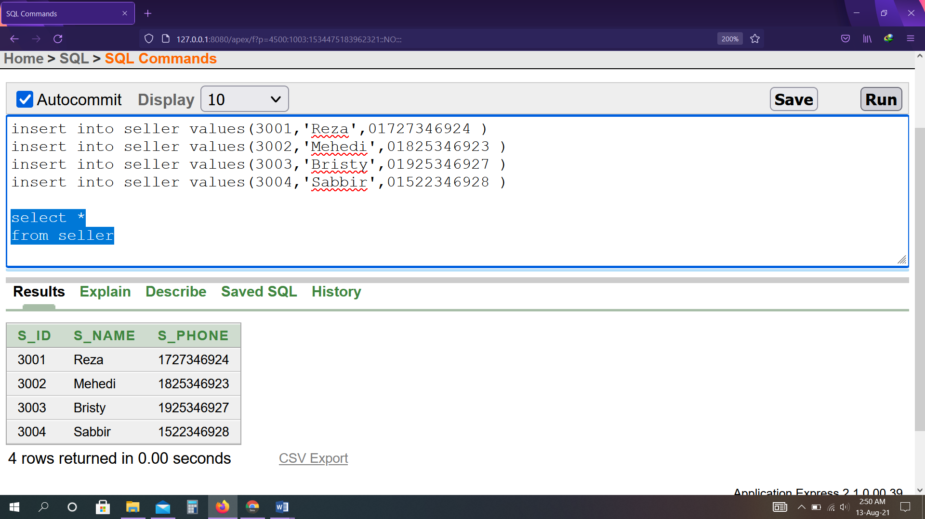

insert into byer_num values(1001,01726546926 )

insert into byer_num values(1001,01623543929 )

insert into byer_num values(1002,01526546923 )

insert into byer_num values(1003,01826546921 )

insert into byer_num values(1004,01526546920 )

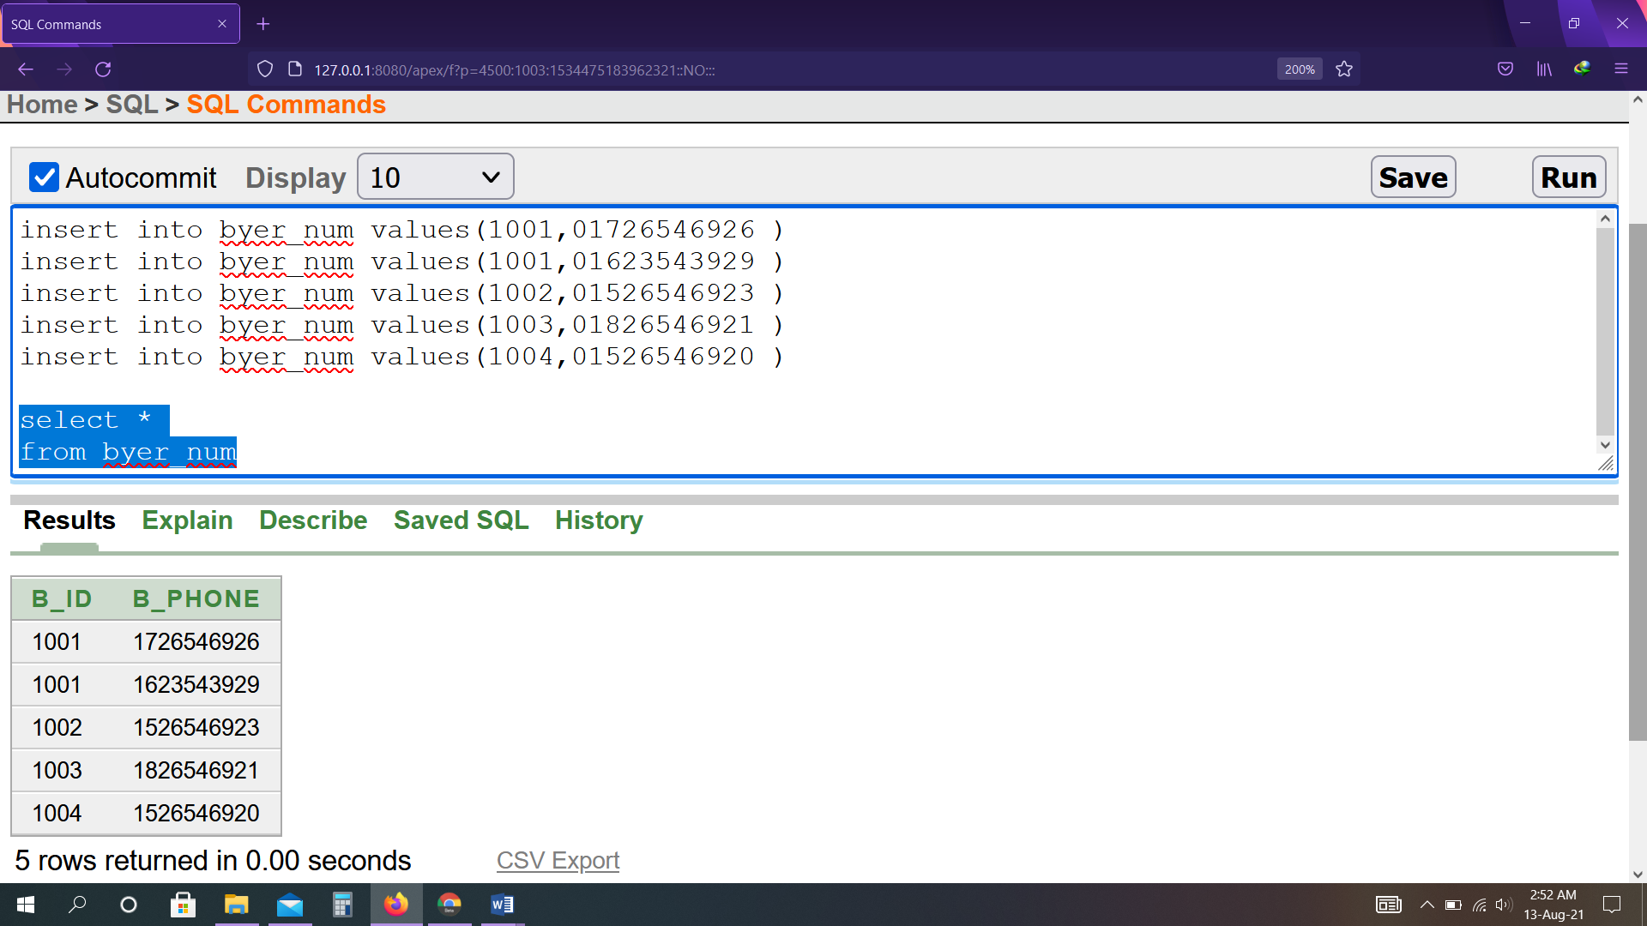

insert into seller_lang values(3001,'Bangla' )

insert into seller_lang values(3001,'English' )

insert into seller_lang values(3002,'Hindi' )

insert into seller_lang values(3003,'Arbi' )

insert into seller_lang values(3004,'English' )

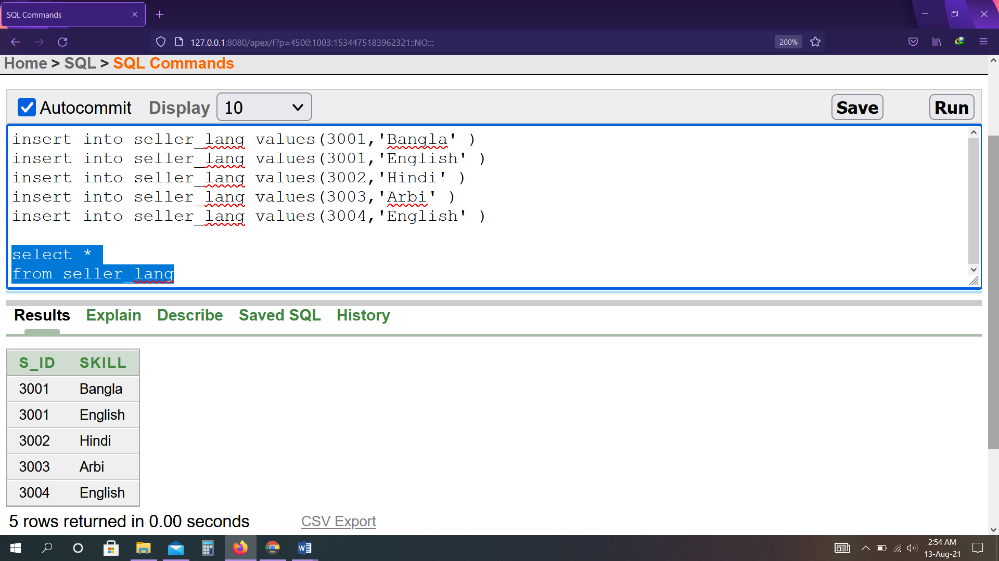

insert into byer_1 values(1001,'Alif',4001,5001)

insert into byer_1 values(1002,'Rana',4002,5002)

insert into byer_1 values(1003,'Fariad',4003,5003)

insert into byer_1 values(1004,'Niloy',4004,5004)

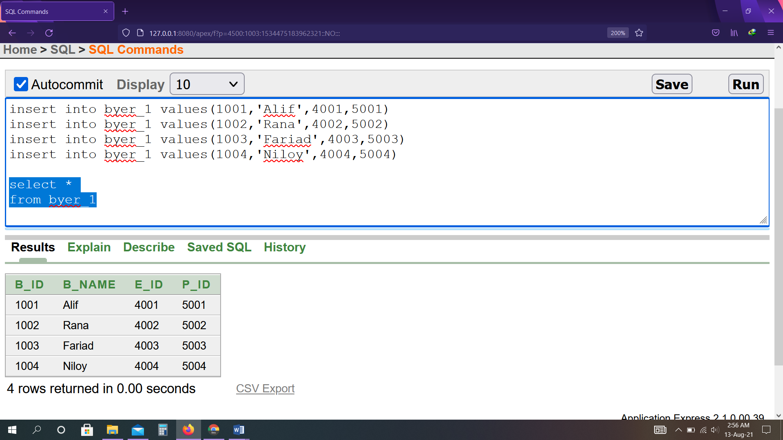

insert into bio_byer1 values(4001,'Dhaka','Bangladesh')

insert into bio_byer1 values(4002,'Delhi','India')

insert into bio_byer1 values(4003,'Riyadh','Saudi Arab')

insert into bio_byer1 values(4004,'New york','America')

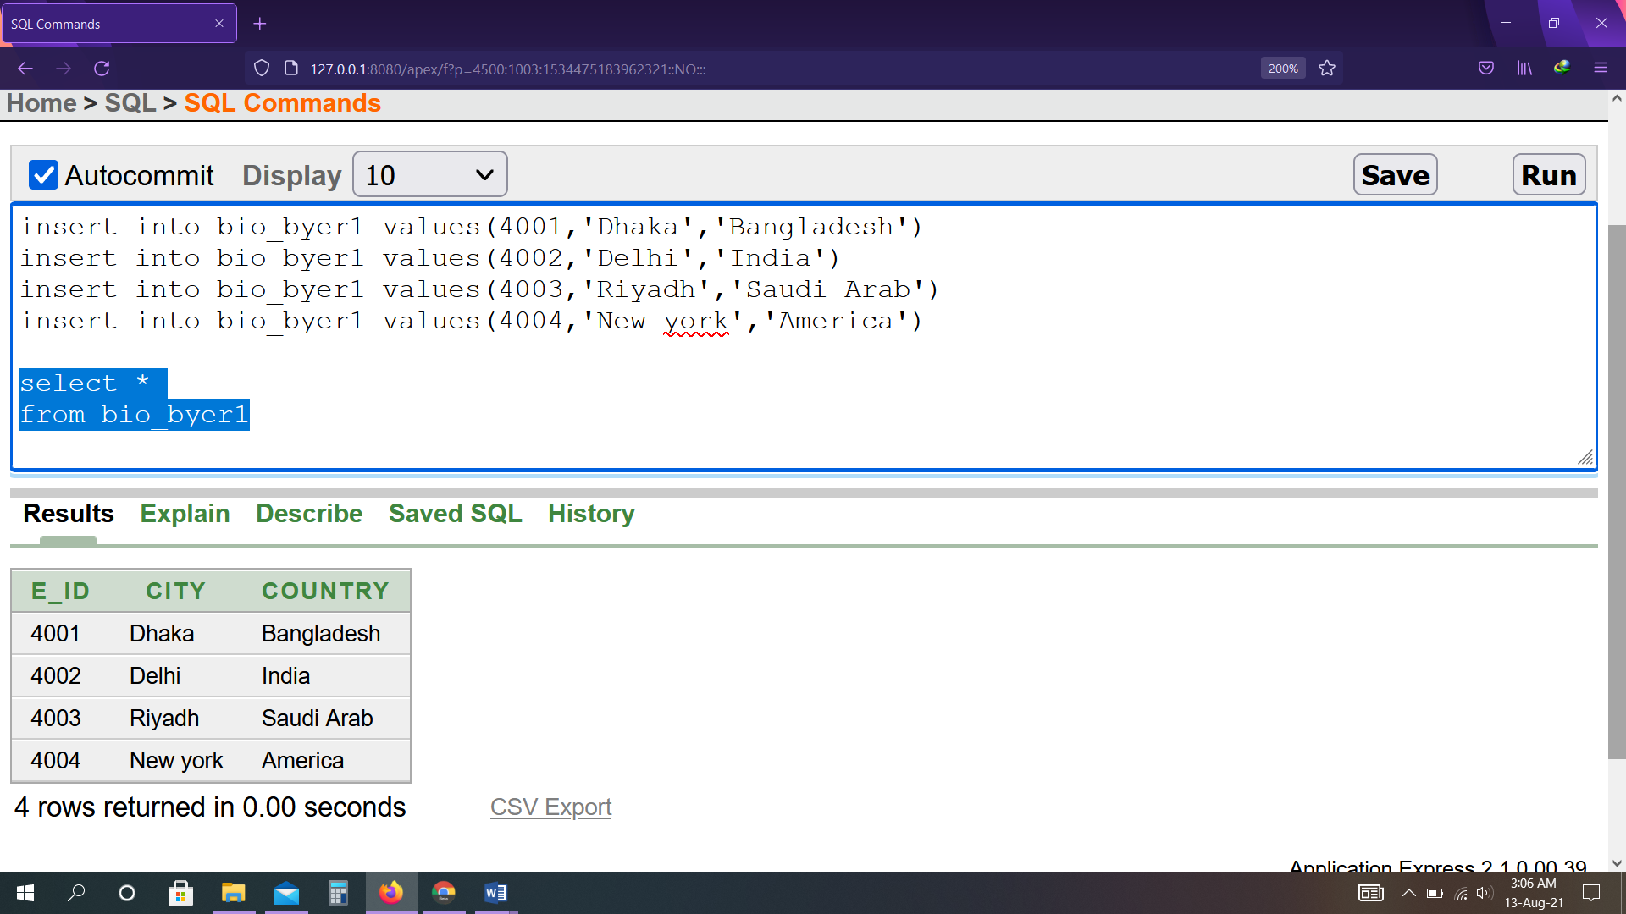

insert into payment values(5001,20000.00,'4-jan-20')

insert into payment values(5002,30000.00,'14-jun-20')

insert into payment values(5003,25000.00,'20-feb-20')

insert into payment values(5004,29000.00,'18-jan-20')

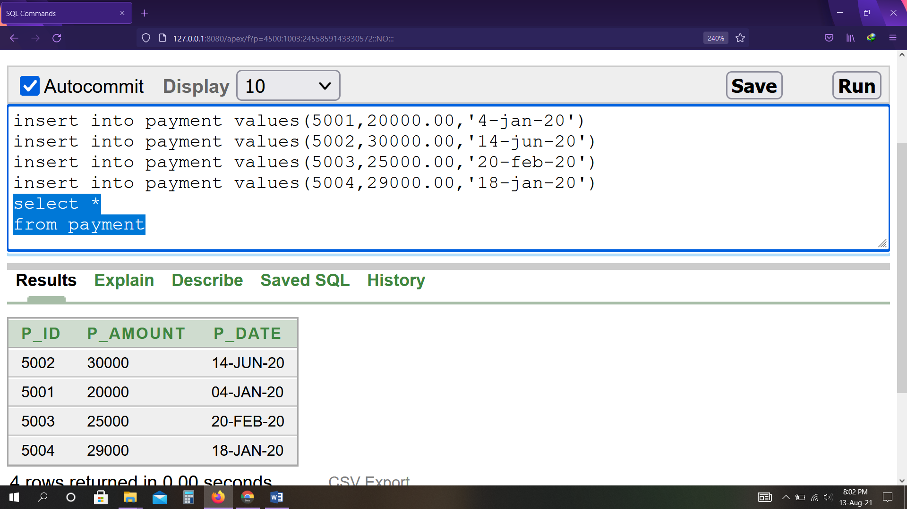

insert into seller2 values(3001,'Reza',01727346924,7001 )

insert into seller2 values(3002,'Bristy',01825346923,7002 )

insert into seller2 values(3003,'Mehedi',01925346927,7003 )

insert into seller2 values(3004,'Sabbir',01522346928,7004 )

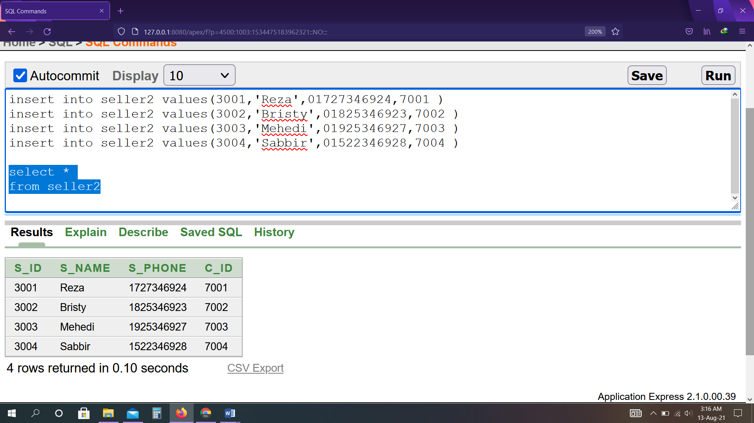

insert into client values(7001,'Abir',1000.00 )

insert into client values(7002,'Mahadi',1500.00 )

insert into client values(7003,'Uchassh',1200.00 )

insert into client values(7004,'Shoaib',1700.00 )

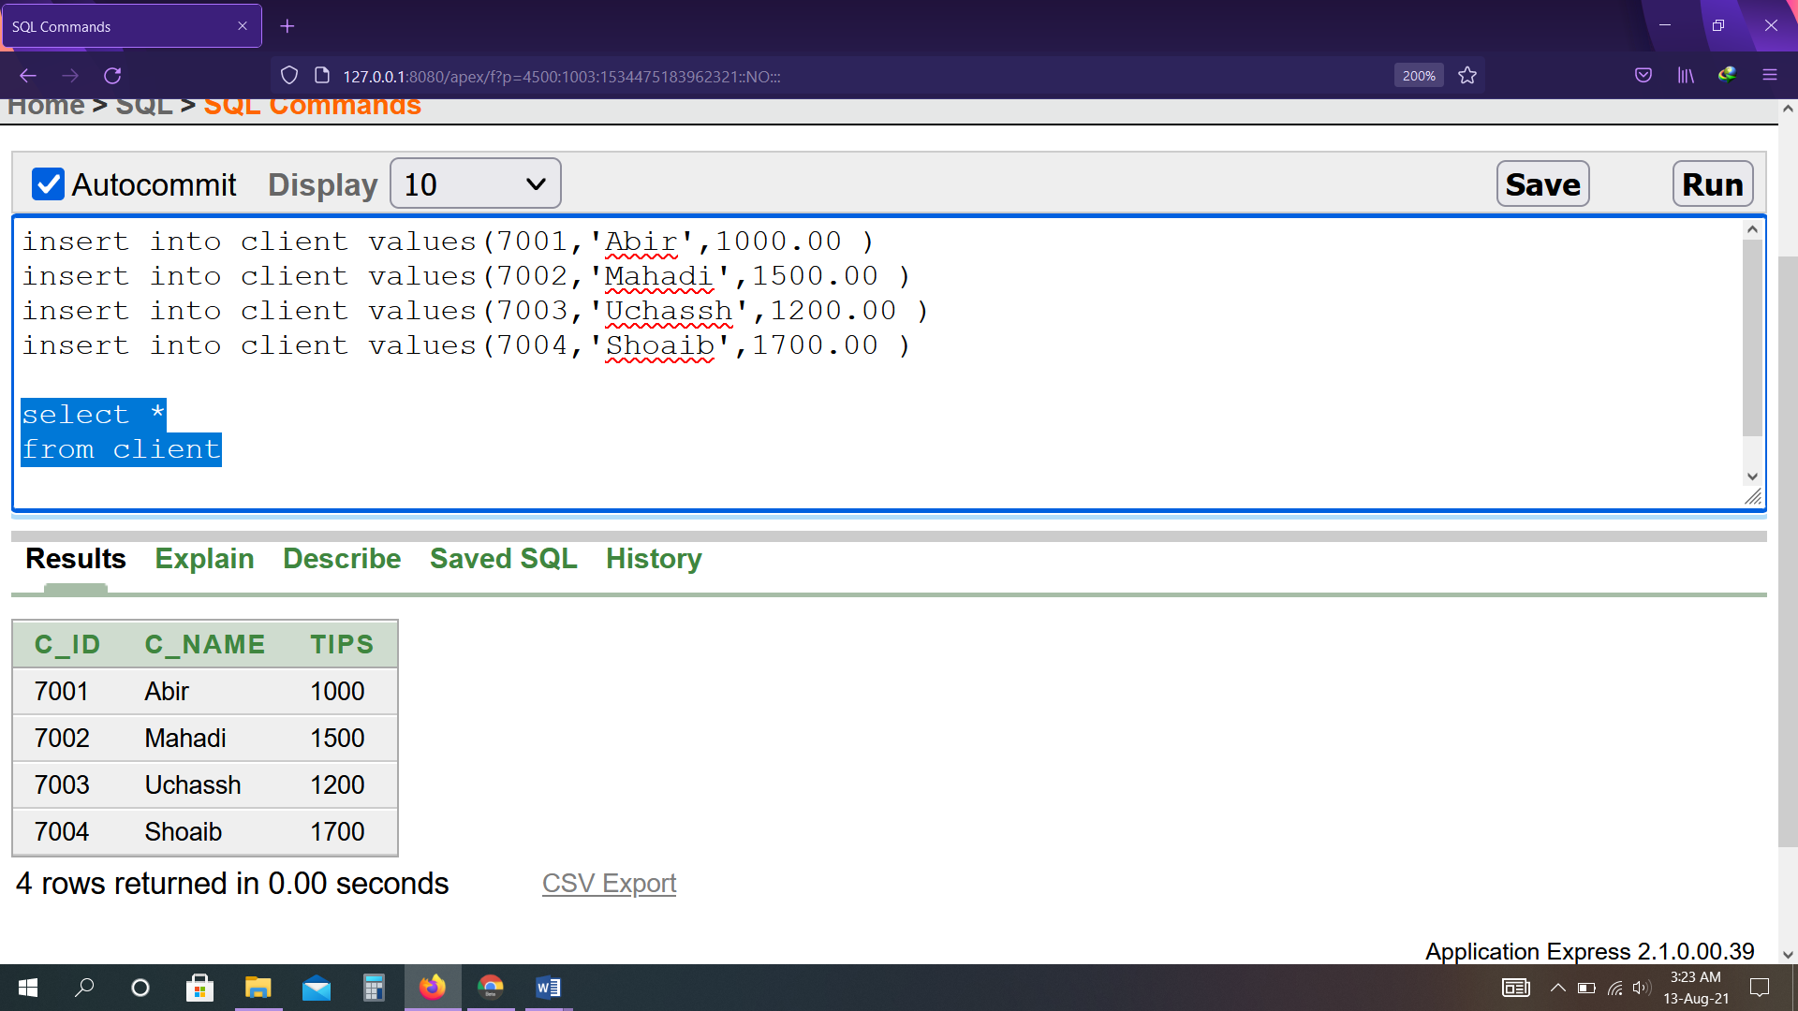

insert into bio_client values(7001,'Abir69@gmail.com' )

insert into bio_client values(7002,'Mahadi64@gmail.com')

insert into bio_client values(7003,'Uchassh12@gmail.com' )

insert into bio_client values(7004,'Shoaib43@gmail.com' )

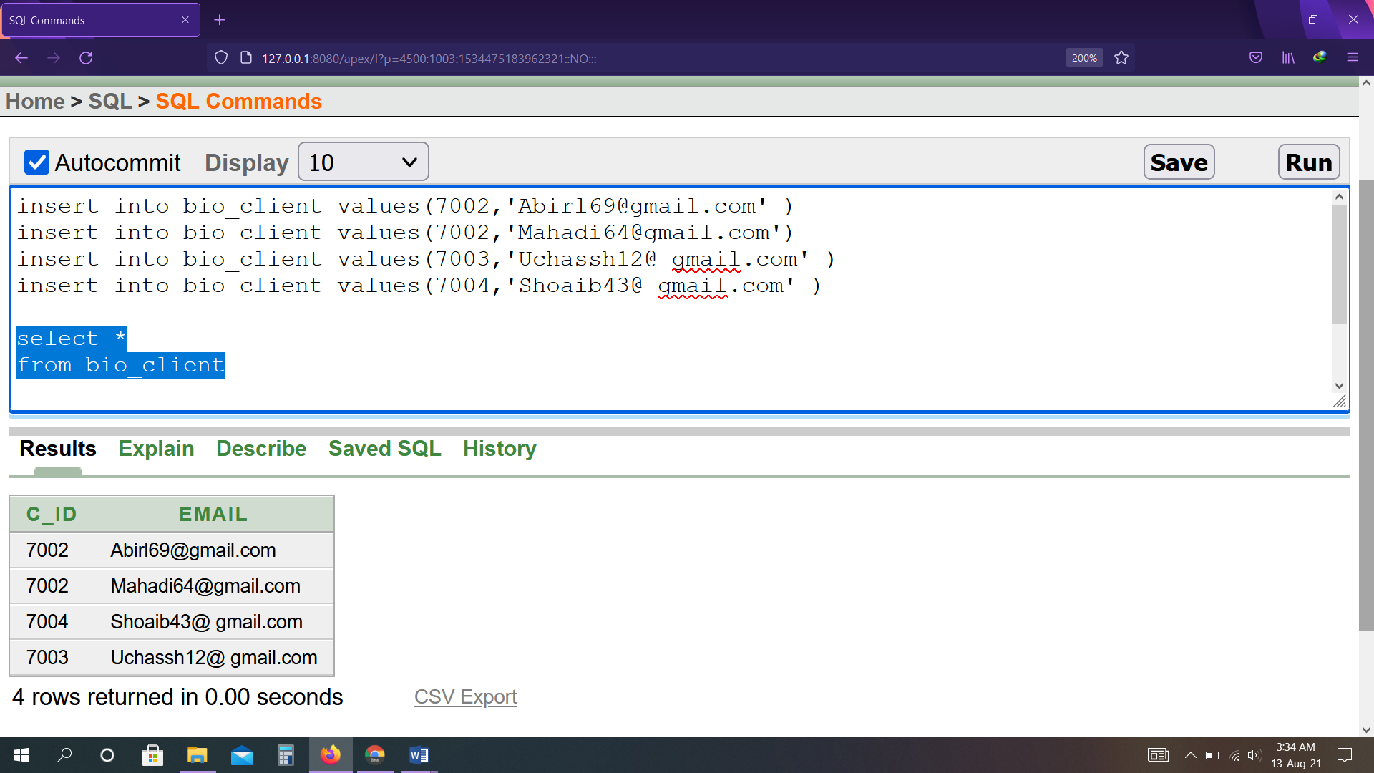

**Subquery**

1. Display all id, amount & date from payment where payment amount is equal to maximum amount.

select p_id, p_amount, p_date

from payment

where p_amount in (select max(p_amount) from payment)

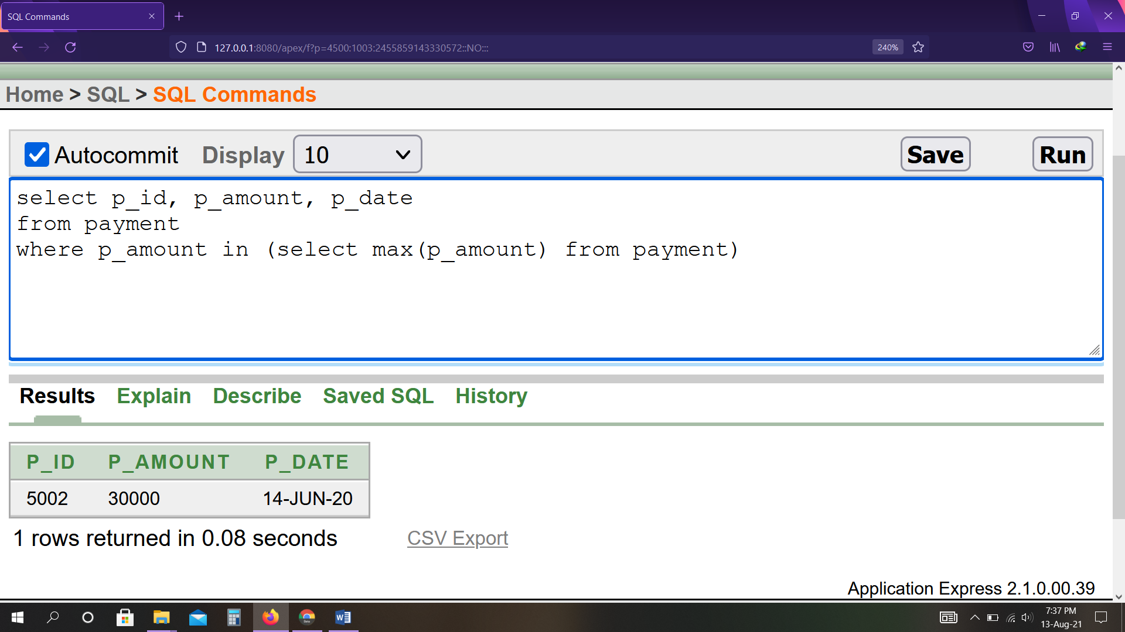

1. Display all id, name & tips from client where tips is equal to minimum tips.

select c_id, c_name, tips

from client

where tips = (select min(tips) from client)

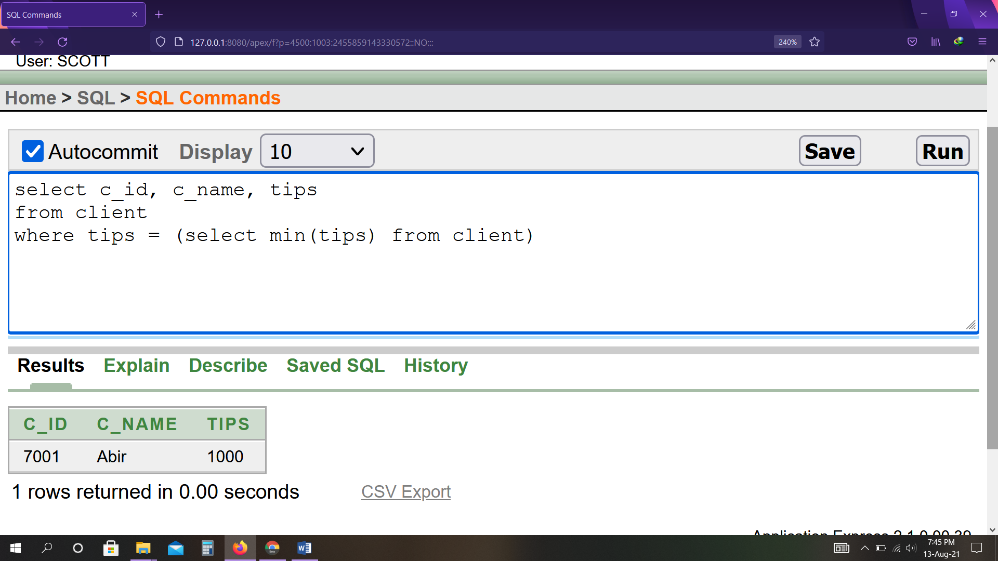

1. Display all id, name, phone number & date from seller2 where seller name is related to client id=7002.

select s_id, s_name, s_phone, c_id

from seller2

where s_name = (select s_name from seller2 where c_id=7002)

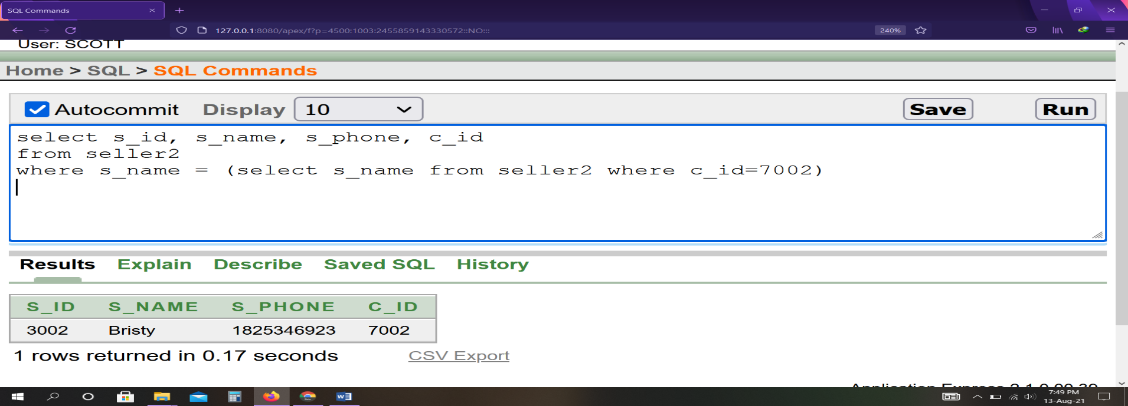

1. Display all b_id, name & l_id, s_id from byer where byer name is related to byer id=1003.

select b_id, b_name, l_id, s_id

from byer

where b_name in (select b_name from byer where b_id=1003)

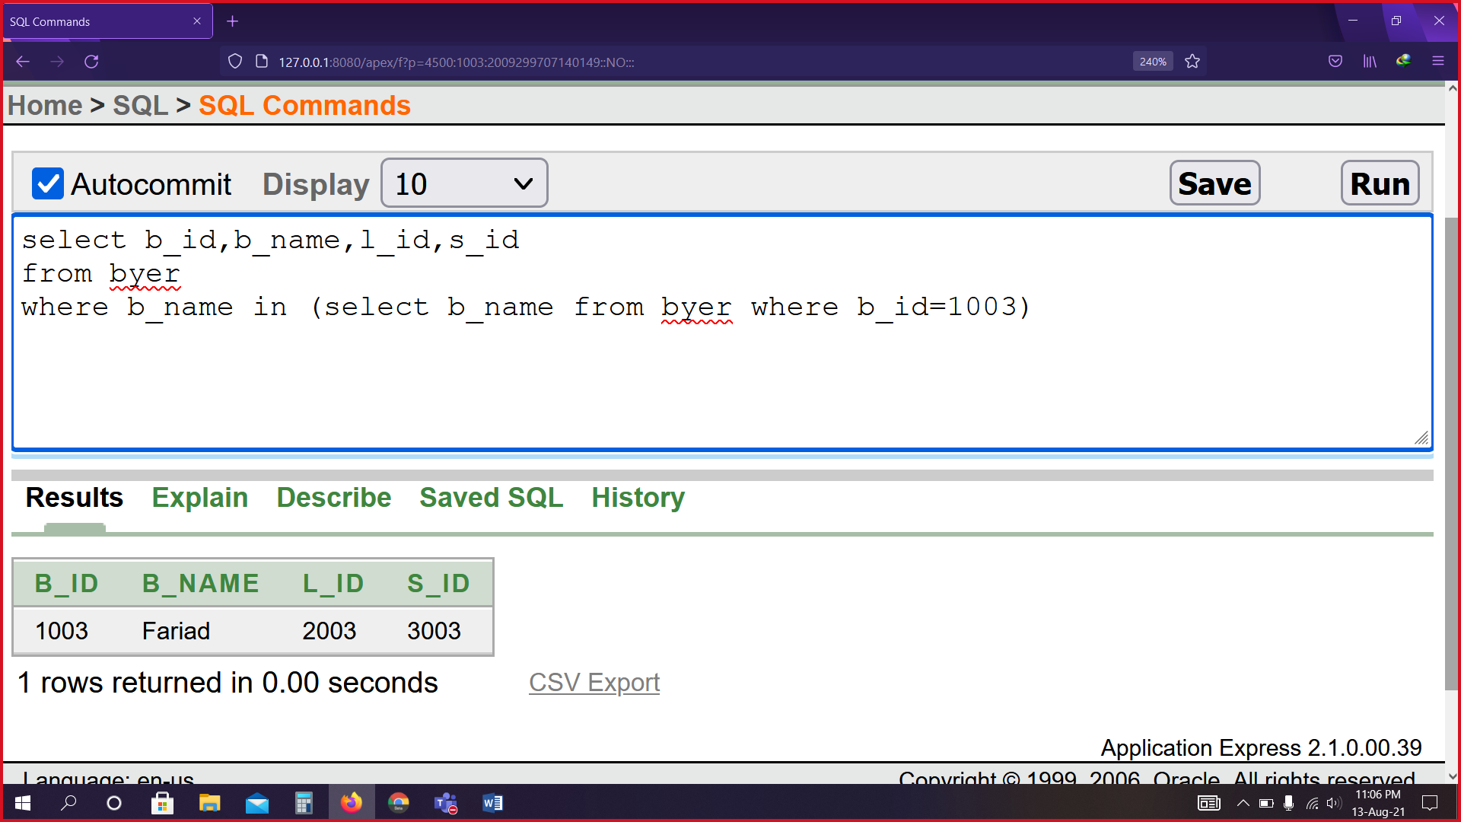

**Joining**

1. Get all byer id, name & country from both tables byer_1 & bio_byer1 and city in Dhaka.

select b_id,b_name,country

from byer_1,bio_byer1

where byer_1.e_id(+)=bio_byer1.e_id and city='Dhaka'

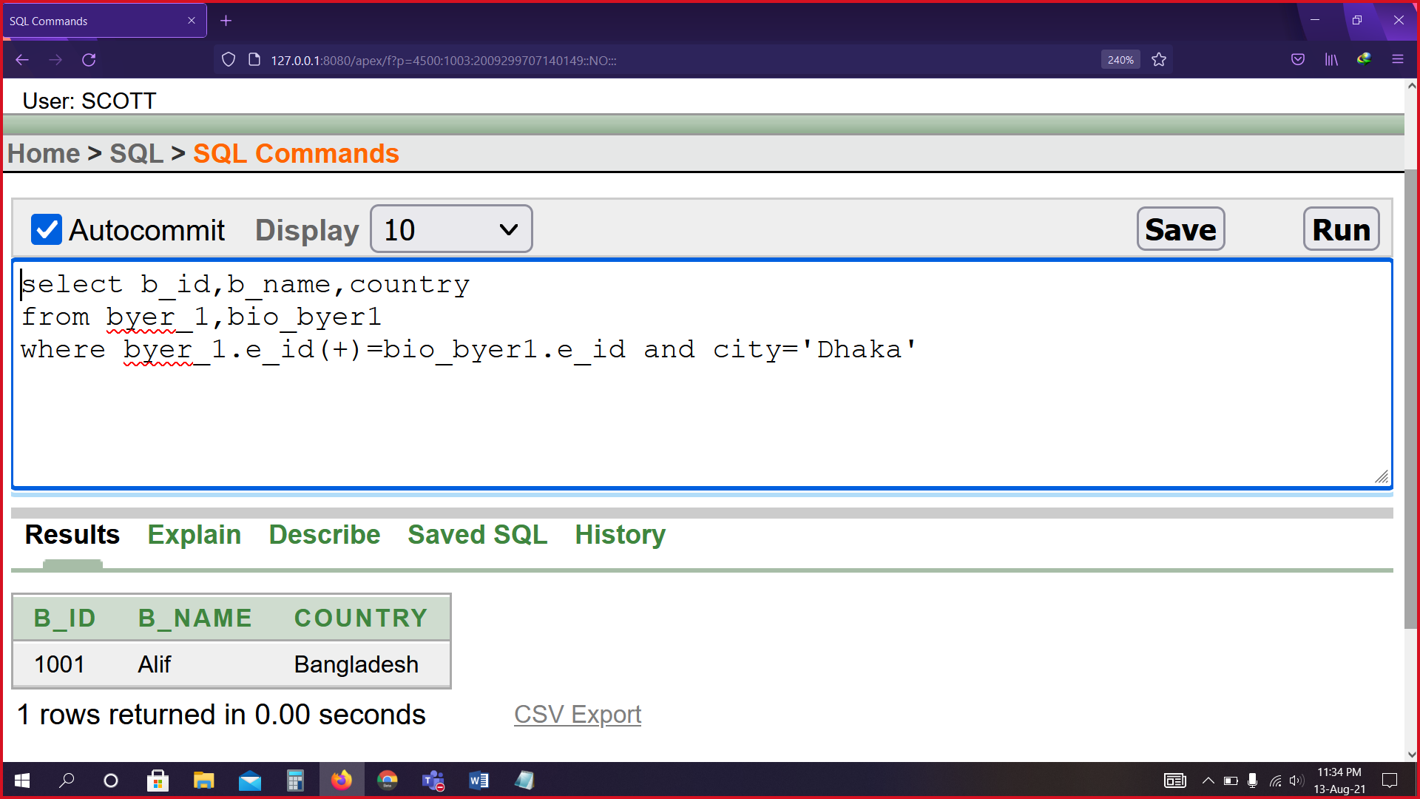

1. Select seller name, id & byer name from byer & seller tables who has seller id=3001.

select s_name,b_name,byer.s_id

from byer,seller

where byer.s_id=seller.s_id

and byer.s_id=3001

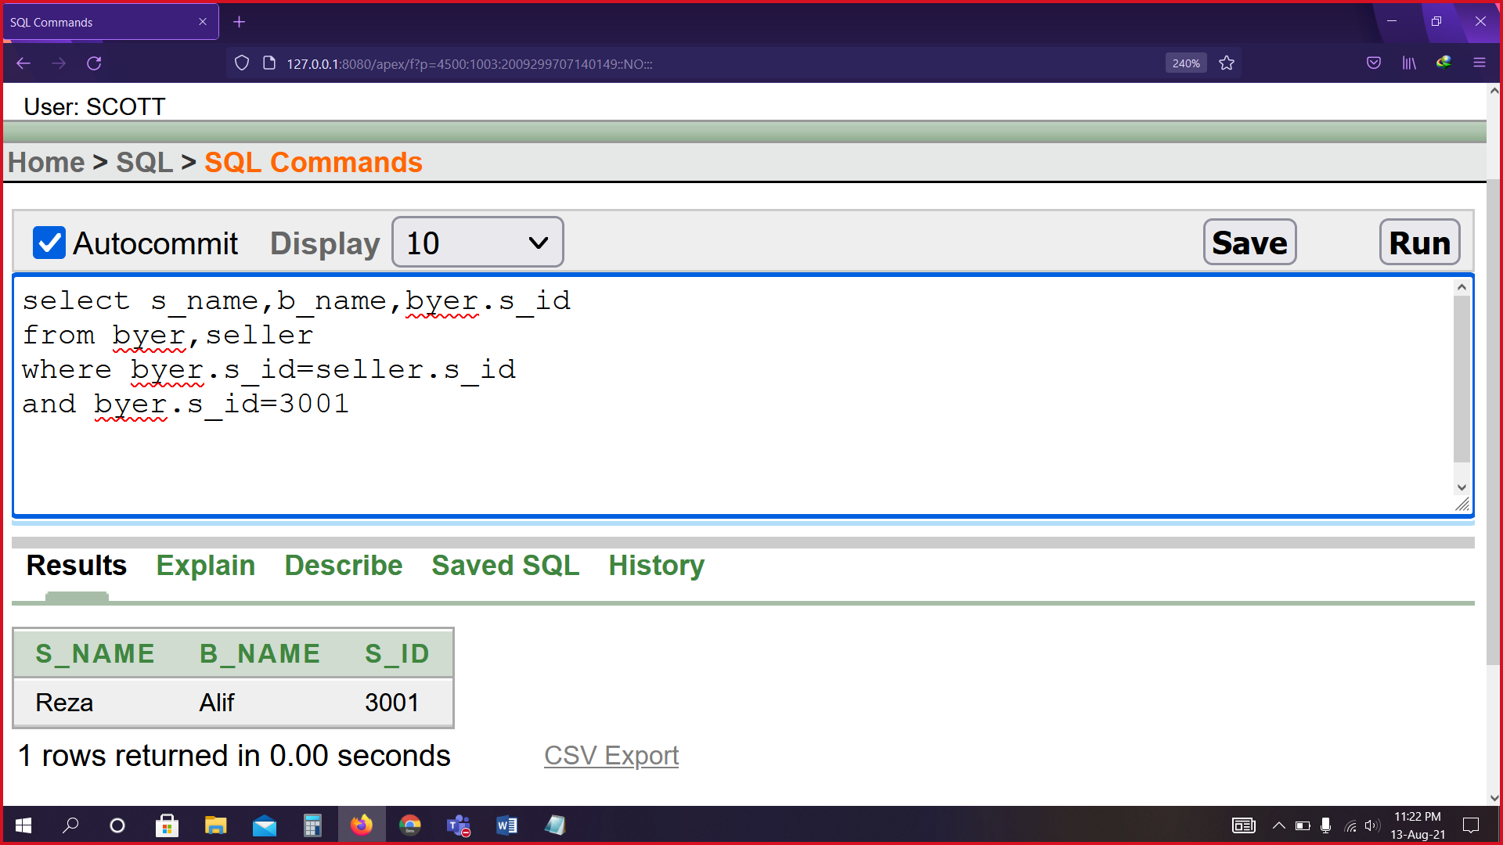

1. Select seller id, name & client id where seller has the phone number= 1925346927.

select a.s_id,b.s_name,b.c_id

from seller2 a, seller2 b

where a.s_id=b.s_id and a.s_phone=1925346927

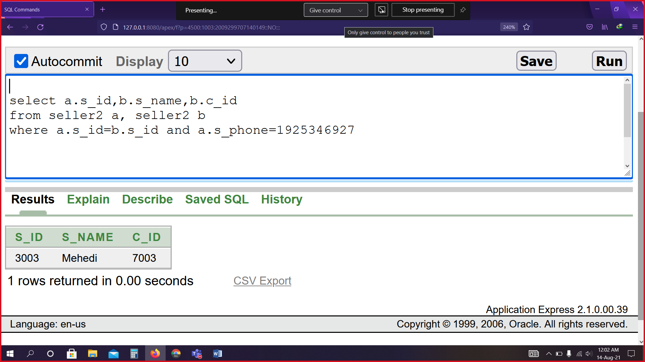

View

1. Create a view called test_view based on payment id, payment amount from payment table where payment amount is equal to minimum amount.

create view test_view

(name, min_amount)

as select b.p_id, MIN(p.p_amount)

from payment b, payment p

where b.p_id = p.p_id

group by b.p_id

